Write-up
Implementation
The problem began with the fact that while doing financial planning this last summer I found that any financial software cost somewhere in the $5,000-$10,000. I didn’t have the money to invest in these types of products so I decided that I would build them myself in excel. The starting point for this project was a worksheet I had used back in a personal financial planning class that does a debt snowball calculation. I then put in some information into the VBA buttons to make sure it worked. Next I wanted to understand the scope of what was needed in a proper financial plan.
I decided it was most important to first do an analysis on taxes. Then combining the remaining income after taxes and debt. Having this remaining balance a budget could be created. Then the next item is to see if the individual has enough in savings to safely weather financial storms. Now that we know if the individual has the proper safety nets we can now look into the first and most important investment is in a home. I want to then find how much money needs to be put away for an investor to have enough through retirement to live the life style they want to. The final steps will be to understand investment opportunities such as real estate and short term investments in sinking funds. Lastly I wanted to add a financial checklist so that while there are not excel items to be completed they have to be done to have a true financial plan.
To continue on with the project, now that the scope has been better understood, I needed to find a website that would allow me to do a web query and retrieve relevant tax data. The largest portion would be to find one that allowed states to be selected and then also get federal data. My initial thought was to look at the IRS website for this information. Sadly the IRS doesn’t believe in posting their tax requirements in nice sections that can be easily pulled from, so I kept looking for some time until I stumbled on http://www.tax-brackets.org/alabamataxtable and http://www.tax-brackets.org/federaltaxtable. The first one allows for the state name to be replaced and a new one to be put in to find a different state. I knew then the VBA would be relatively easy to preform since we did this in one of the first of our assignments. So after creating a new tab for taxes I also set up an input section and an output section. Using my knowledge of taxes I have built a tax schedule for both state and federal. The input section asks for the name, how much their income is, their filing status, the number of dependents, and the state where the income was earned.
The next step was then to build a form that takes in all the variables from the inputs section and then allows you to manipulate them and then puts those back into the spreadsheet. It’s really important that the state is correct for tax purposes as well as for the housing decision tab. I then added another form through a second button that would then run the code to remove the current data and then do a web query for the federal tax data and the state specified tax data. Then it runs the analysis to find what the required taxes will be and put that number in the tax schedule.
The last step for the Tax tab was to find the rates for standard deductions and Medicare and Fica taxes and do some formatting to the page. I tried for some time to find a website that would allow for each year’s Medicare and Fica taxes to be brought in but I need found success. This maybe an item I have to update each year until I eventually find a site that will do this for me. Here is the ending result.
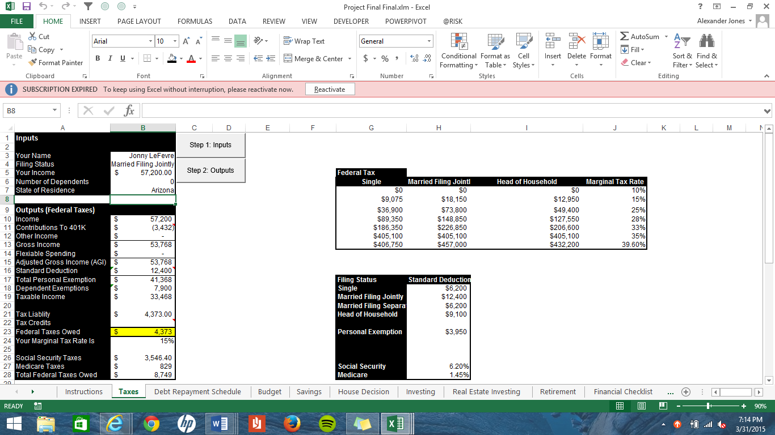
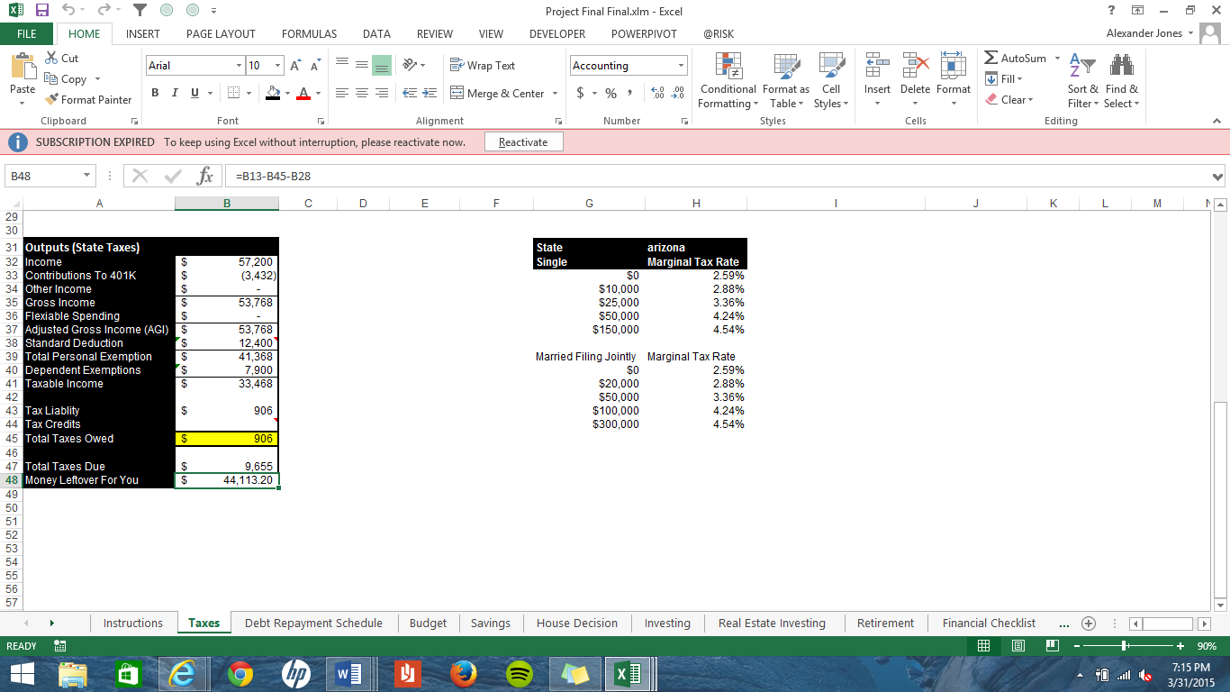
The next sections I will try to be more succinct. The debt repayment section I already stated that I used this from a prior class. There is a lot of VBA in this tab but I can’t take credit for most of it. I merely changed the formatting that was done in VBA so that it flowed better with the other sections. This tab allows you to input your debts and builds a debt snowball table. The total debts are then put into the next tab for budgeting. This one required no VBA but is very important into understanding personal finances. This tab is an area that I will talk about further in learning and conceptual difficulties. The next tab is savings and this tab takes the savings amount put in, in the budgeting tab and then gives the reader advice about what to do with their savings and future cashflows.
The next tab is for the home buying decision. In this tab a form is used again to collect the data currently in the input range and then allow you to adjust those inputs from the form. The outputs are then analyzed for whether a lender will lend on the loan requested. An important factor in this analysis was retrieving the data for each states current property tax rates. That data is then sorted so that when the tax table pulls in the name of the states it is in alphabetical order.
Next on the list is a retirement calculator which uses another form to find what the inputs currently are and then allows the user to make adjustments. This is a useful calculator because it uses data from a FRED add in that brings in economic data. That data is used to calculate inflation rates that are used to understand the retirement requirements for the individual.
Finally comes investing and a checklist. The investing and investing in real estate tabs do not use any VBA and are there more for show then for practical use at the moment. Some VBA eventually will be built into these to take data from a web query on stock data and real estate data to find what the expected returns will be but I didn’t have enough time left to complete that task. The checklist also is not automated but I found it important to have for the purpose of the project. Time was spent on each section formatting to make it have a congruent theme.
Learning and conceptual difficulties
I am not a programmer. This I have learned in great detail during this semester but is apparent in this project again. I probably took two to three times as long to accomplish the tasks in VBA then would take the average student, but I learned that I am capable of doing hard takes in excel using VBA and even found that with VBA I could do things I couldn’t do with just formulas. Integrating forms in this project have been the most useful to me as it really helps to narrow down the required inputs for a large excel page. One task I wish I could have spent more time on would be to link the budget category to mint.com so that I would be able to pull in the actual data for a budgeted month and then do a comparison analysis to what was budgeted. I don’t know if it was a lack of understanding how or just the time to complete the task that forced that to fall by the way side.
Another area I had a difficult time with was how to do the checklist automated. I didn’t want to spend the time on this section either as it seemed inconsequential to the overall usability of the project. If I had really had the time I would have had another button on the first page that would build out the other pages automatically with formulas and all but again time constraints came into play. I would say there wasn’t anything I couldn’t do without a little research and help from class notes. I have truly enjoyed what I have learned and I am grateful for this class.
Assistance
The only assistance used for this project was the borrowed excel tab for debts and another student helped with the formatting.

