Exam Study Planning Tool

Executive Summary
As an actuarial science student I have to periodically take certification exams as I progress through my career. An actuarial exam is usually 3-4 hours long and it is suggested to study about 100 hours per exam hour. It can be very difficult to plan far in advance how to study for these exams. My new exam study planning tool will help solve this issue. My tool creates a calendar and study plan for the user, keeps a log of the study progress, and tracks the study progress towards the study goal.

Implementation Documentation
Under the “Study” tab in the Excel ribbon, there is a button that is called “Create Study Plan”. This is where the tool begins.
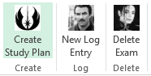
Upon click the “Create Study Plan” button, the user is prompted by the following user form.
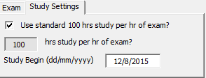
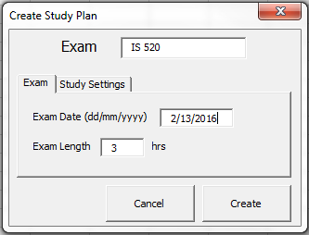
The user can then fill out the information about their exam. It is required to have all fields filled (although some fields are defaulted). The fields are the name of the exam, the date of the exam, the length of the exam, the day to begin studying, and the hours per hour of exam to study. Once the information is complete, the “Create” button will create the exam study plan.
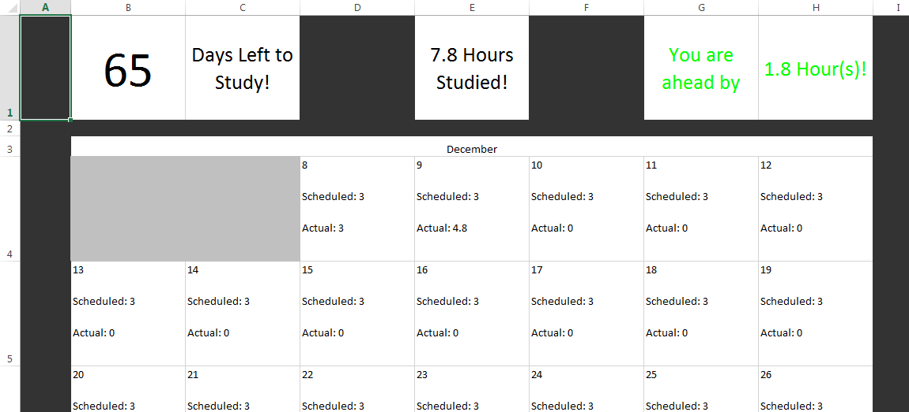
As you can see from the picture above, a new sheet is created that contains a calendar with the scheduled number of ours to study, and the actual hours studied. The scheduled hours are derived from an algorithim I wrote that starts the study off slow and then increases the study time at junctures in the study plan (the time is basically broken into thirds and each third increases in time).
The create study button also creates a separate sheet that becomes a log for the study completed.
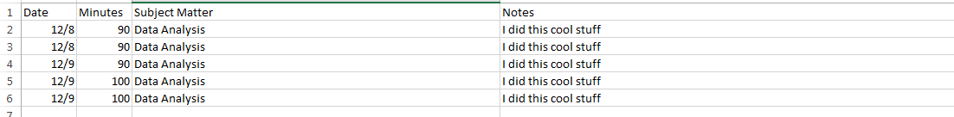
Log entries are entered using the “New Log Entry” in the “Study” tab. The log contains minutes studied, material studied, date, and any notes.
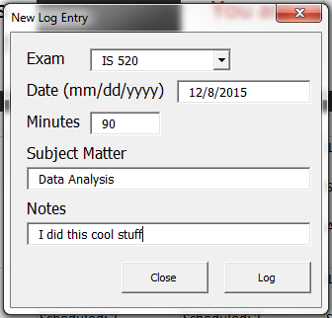
After each log entry the calendar page is updated and at the top of the calendar there is a tracker that tracks the number of days until the exam, how far ahead or behind of schedule you are, and the total hours you have studied. There is also a third worksheet created by the first button that is hidden from the user that keeps track of the study plan and the progress toward the goal. I have often wanted a log to keep track of my progress and a place to keep notes (problems to revisit, important things to remember, etc.), the log and calendar together will be able to accomplish all of this in one place.
The last button deletes all of the pages associated with an exam, including the hidden one.

Discussion of learning and conceptual difficulties encountered
I learned a wide range of material while I built this tool, but the ones I think I learned the most about were user forms and arrays. I really grew to appreciate how difficult it is to validate data coming from a user form. It is hard to think of every way that a person could input invalid data into every field. I also had to use a lot of arrays and loops and the practice helped ingrain into my mind how these function.

Assistance
I didn’t receive any assistance on this project.

