Kevin Geddes
Executive Summary:
I developed a program to assist my Sister in being a more effective shopper. With four children and many personal projects of her own, shopping is a constant source of pain in her budget. She requested a tool to help her keep better control over what is happening with her shopping. She asked me to create a project to help her keep track of how she is spending money on groceries and other small ticket items that are usually lumped together in budget programs. She had created a spreadsheet where she been putting all her purchase before, but it was not very efficient. From the structure she had developed I designed a program that serves as both a custom shopping list developer and a purchase analyzer.
Within the workbook there are two individual worksheets that serve as databases. The first worksheet serves as a comprehensive shopping list where she inputs all the details of every item she wants to purchase so she can know about how much she will spend on her shopping trips. The second worksheet serves as a database for her to input the details about each individual purchase from her shopping trips. A third worksheet serves as a way to make pivot tables and pivot charts to analyze her data by month, by item, or by whatever else she wants.
Implementation Documentation:
The idea behind the entire design of this program was to create a program that would be fun for a mother to use so that they would continue to use it. To that end I included lots of bright colors and entertaining fonts to try and make it cute. I assumed that they would not be using this program for long periods of time, and that this color scheme for the user box especially would not strain the user’s eyes.
When a user opens this workbook for the first time they should use the Shopping list function to develop a comprehensive shopping list that they can further customize for each shopping trip. This begins by selecting the Analysis ribbon and clicking on the Create Shopping List Icon in the Shopping List category.
Ribbon A – Creating a Shopping List
Next the user is presented with User Form A (shown below) which allows the user to put in several details that will prove valuable as they create custom shopping lists in the future.
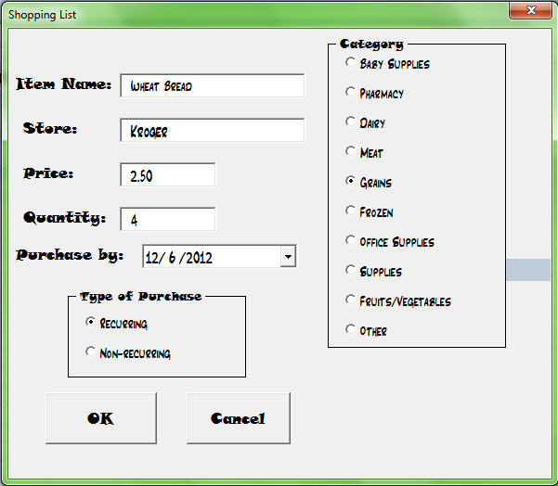
User Form A – Shopping List details
All of the information here is input into a table, allowing for the creation of a category or store specific shopping list. If the user can only go to the grocery store and the pharmacy at Walmart that day, the detail in this user form allows them to develop a shopping list customized for that particular location with the current needs of the family. The purpose of the purchase by date and the recurring/non-recurring options allows for more ways to customize the shopping list for the user.
The shopping list worksheet before developing a custom shopping list would look like the picture below:
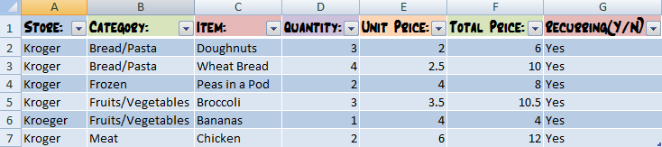
Table 1 – Shopping List
After purchasing an item they can delete that line from the worksheet and the next item that is input in will fill in that line. Additionally if you buy everything on the shopping list there is a button on the ribbon called ‘Clear Shopping List’ that will clear all the data on the shopping list except the header line, which keeps the cells below formatted as a table for analysis of future items.
When the user has purchased items they then input those specific items on another spreadsheet using the button in the Analysis ribbon called Input Purchases, which is highlighted below. 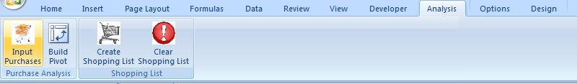
Ribbon B – Purchase Analysis
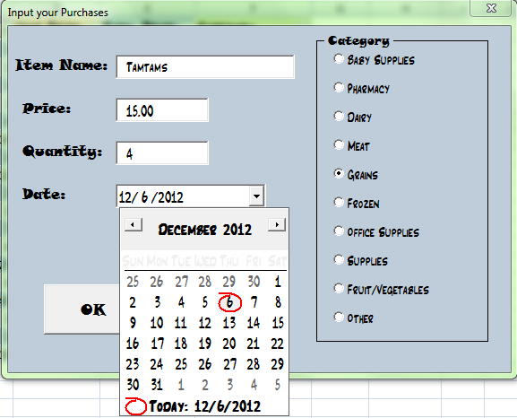
After they click that button on the ribbon User Form B will appear. This form is a little simpler because it has the express intent to analyze the money spent in these categories over a period of time. The date function assumes that the user will input their purchases the day of the purchase and sets the date to the current date. If they wish to change the date, this calendar is attached that allows the user to select whatever date they need. All this data is put in a table like the one for the shopping list, the difference being that there are much fewer categories this time. When the user has created the table they can then build a pivot table from their data by clicking the Build Pivot button in the Analysis tab. Then they will be presented with pivot table similar to the one below. This specific Pivot table is set to look at items purchased between the 12/1 and 12/15. This table can easily be converted into a graph for easier viewing thanks to a built in excel function on the ribbon.
User Form B – Purchase input details
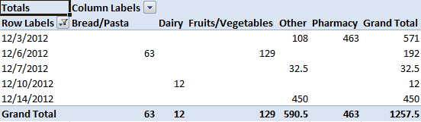
Pivot Table 1 – Analyzing spending habits
This functionality allows the user to know how much they spend in a certain time period in certain areas so they can both determine where they should cut back and how much they are spending over a specified period of time. They can also do an analysis of the spending on different items in different parts of the year.
Discussion of learning and conceptual difficulties encountered:
The first challenge of this project was thinking of an effective design that would meet the expectations that my Sister had for the program and that would be logical. I looked for ways to streamline the presentation of the information so that anyone would be able to look at the information and be able to understand it. I also wanted to create a program that would be easy to understand and use so that people without many computer skills would be able to operate it. I learned more about making a program user friendly through the design of this program. I became much more familiar with how to connect the user form with the sheet so that whenever my sister opens this workbook that it will be ready for use, and she will be able to pick up right where she left off.
The largest challenge I had was with developing the Pivot Table. Even though I recorded the creation of a pivot table again and edited it like we did in class my pivot table still was having problems with the create pivot function. I went online and looked at several other examples to see what they did with their pivot tables to make them work. I tried a variety of the solutions presented online and compared my code with the code from pivot tables we have used or created in our class. Ultimately after a lot of trial and error I learned how to format the pivot table and place it on a specific sheet. I learned how to refer to a dynamic range that the pivot table to draw from when creating the table. Additionally I learned how to remove an old pivot table from a worksheet and put in a new one. Each of these items I learned came about after struggling with these ideas for several hours each and then finally coming to a solution. Through this process I learned that sometimes a workbook just gets tired of being abused and that I need to open a new workbook input the code there, and then try over again. Such was the case with one of the problems I was having with my code when VBA kept sending an error message that the object method could not be called or that an object variable was not working.
The third largest learning experience was learning how to add a custom ribbon. I created a ribbon for two different workbooks and they were working for awhile and then on this specific workbook it stopped working. I tried using code from other homemade ribbons on our assignments, from custom ribbons, and from the ribbon wizard, but for some reason the workbook would not save the code. Eventually I just put the ribbon in another workbook and transferred my code to that workbook and the ribbon has worked ever since. Through this process I came to understand what elements were involved in creating a new ribbon in excel. Through this project I learned a lot about problem solving and about seeking out answers online. I also learned how rewarding programming can be when you can see a finished product and remember all the work you have put into a project. To see it running smoothly and fulfilling its purpose is exhilarating.
Assistance:
The only person I really got help from was Professor Allen. Otherwise the only real help I received was from the book and through code I found online.

