Jake VanDyke
Final Project Write-Up
Warm Springs Retreat
Executive Summary
Warm Springs retreat is a resort that has several rental units (large multi-family lodges to 1 room cabins) available to stay in. The resort is owned by my cousins, but they no longer are involved with the management of the resort. Currently, reservations are kept track of with a large paper calendar, and to find out what openings are available the customer needs to call the secretary and ask for the information. In addition, the secretary is very computer illiterate, leading management to believe that there is no solution to this problem. The project solves both of these problems by using forms to create calendar months, add, edit and delete reservations. The calendar is saved and uploaded to the server for easy viewing over the internet by simply pushing a button.

Implementation
To start the program, open “finalproject.xlsm”. Hopefully you will notice 2 new buttons located on the home tab, which look like this:
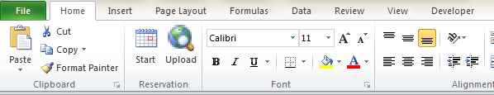
Clicking the start button will begin the reservation system by bringing up this form:

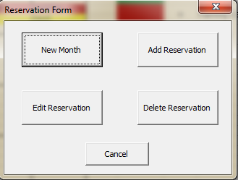
These are the 4 basic actions which the program is capable of: Adding a new month, adding a new reservation, editing a reservation and deleting a reservation. All 4 processes will ask for some basic information, and then automatically complete the action wanted. Here are some examples:

Clicking New Month will bring up this form:
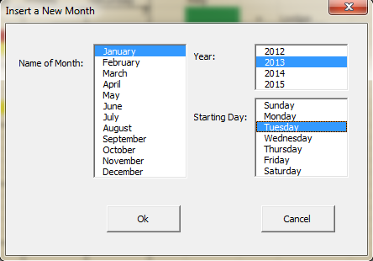
The user will need to select a month, year, and starting day, which the program will use to build the new month’s calendar. If one of the options is not selected before clicking okay, the user will be told which value was not selected, and will have to select a value before they can move on. This example will make a new calendar for March, 2013, with the month starting on Friday, and will look like this:

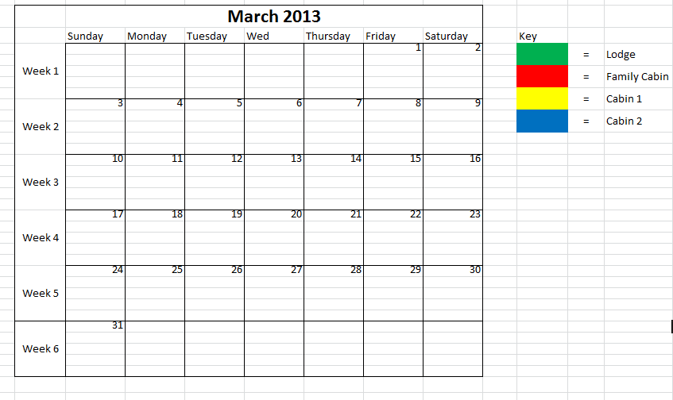
If the user attempts to create a new calendar for a month that already exists, the user will be told said month already exists, and will need to choose another one.

The next step is adding reservations, which is done by clicking the start button and then Add Reservation, which pulls up this menu:
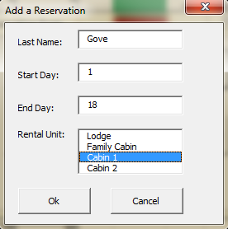
With this information, the program will add highlighted cells from the 1st till the 18th, with the text ‘Gove’ also appearing in the cell. The highlight color will be the same as that found in the key next to the Calendar, and can be changed to whichever color the user wants. The end results look like this:
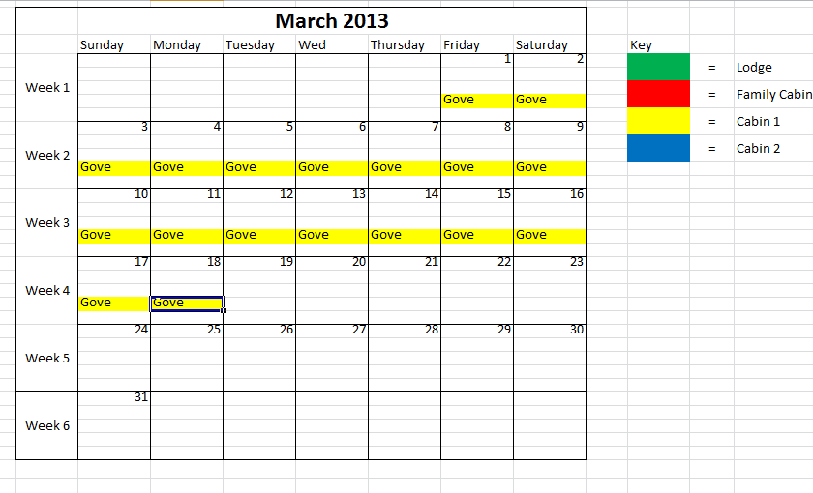

If Gove calls back at a later time and wants to change his reservation, simply click start, and then edit reservation, bringing up this menu:
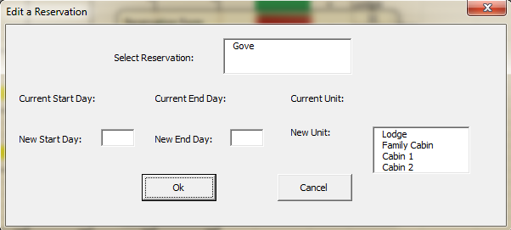
The Select Reservation list is populated from the reservations on the selected month. When you select a reservation, the Current Start Day, End Day and Unit values are automatically pulled in, and any of the 3 can be changed to what is needed, including simply changing which unit the customer wants to stay in. If the customer needs to completely delete their reservation, again click start and then Delete Reservation, bringing up this form:

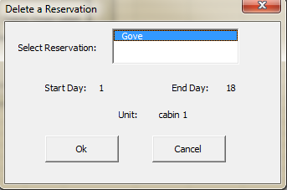
Again, the reservation list is populated from the reservation on the selected calendar, and when a name is selected the other values are then populated. When clicking okay, the user is asked if they are sure they want to delete the reservation, and upon confirmation the cells affected by this reservation are changed back to empty white cells.

Finally, after all of the changes have been completed for the current month, the user can then click on the Upload button which will save the calendar as a .pdf file and then upload the pdf to the server so that potential customers can see which units are available for rent and on which days.

Learning and Conceptual Difficulties
The main learning that happened while completing this project was a cementing of ideas that were taught throughout the class. One of the first assignments was working with highlighting cells, which I had to review and study in order to get the highlighting to work on the calendars. Another issue was working with loops. I attempted to use for loops to help populate all of the lists in the menus, and found that for loops do not work very well, because in many of the lists I was deleting duplicates. This changes the .listcount property, and resulted in errors, which were solved by using for loops, and creating my own exit conditions. This helped solve another problem when initializing the calendars. I have a loop within a loop in several places, and because I was using my own exit conditions, it was simple to add another exit condition in order to completely exit both loops when needed.
One of the main conceptual difficulties was that of using vba to upload a document onto a server. I already knew how to build websites and use an ftp agent to upload files to a server, but I had never used windows command prompt. I have since learned some of the basic commands in command prompt, and have begun to learn about batch files and the shell command in vba.
Another area of learning was using excel templates. I created and saved the basic outline for the month as a template, and when creating a new month I would use the information given and edit the new sheet to become the new month. The problem was that when opening a template, it opens it in a new workbook, and the name of it changes. This was a large problem at first, because when adding several months, I would have a large amount of excel files open. To fix this after copying the sheet into the final project workbook, I would save the template workbook as JJVD1776 (thinking that this is a very unique name), delete the newly saved workbook, and then close all other excel workbooks except the finale project workbook.

Assistance
I used Google extensively when encountering errors, and when attempting to understand loops better. Dr. Allen helped me get started on how to use vba to upload a file to a server, and further help was obtained from Collin Winget, but I did right all of my own code to get the project working.

Finale Note:
Downloading the project files and then hitting the start button will not work, because some of the file paths are specific to my computer. For example, the template blank month.xltm file path would need to be changed according to where you put the file because I was referencing the template folder on my computer, which is under my username. Also, before uploading I have changed some of the information in the text file that d.bat is running, because it has sensitive business usernames and passwords.

