Valuation of a company. Calculation of NPV and Price Per Share.
Yulia Shaykhulina
This VBA project will allow to reduce time spend on mechanical calculation of NPV, CAPM, WACC and price per share and spent more time on decision making aspects of projects, like preferred capital structure, analysis of growth of EBIT, CAPEX and NWC.
User opens a spreadsheet with VBA.
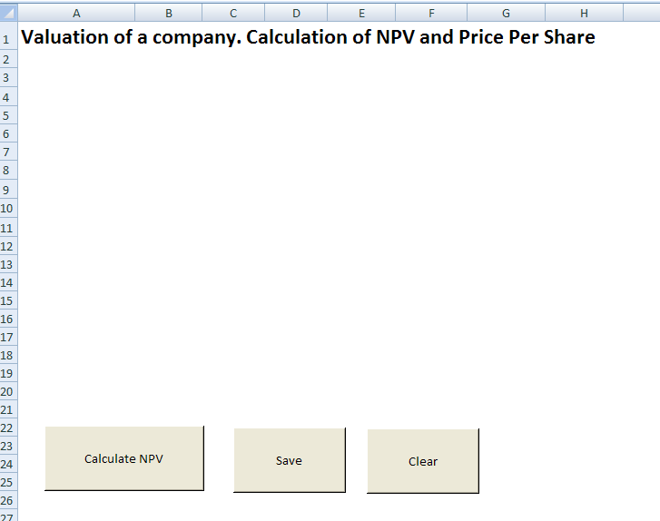
Then user should press button “Calculate NPV” and enter all required data in to the form “General information about the company”.
Number of periods – period for which Discounted Cash Flows for the firm are evaluated
Cash flow.
EBIT – Earnings before interest and taxes. It is a measure of a firm's profitability that excludes interest and income tax expenses. EBIT = Operating Revenue – Operating Expenses + Non-operating Income.
Capital expenditures - money spent to acquire or upgrade physical assets such as buildings and machinery.
Net working capital (NWC) - represents operating liquidity available to a business, NWC= current assets- current liabilities.
Data in the cash flow will be entered into the first year data column of the final table.
Equity
Number of common shares – current number of common shares issued by the company
Preferred stock yield – Dividend per preferred stock divided by preferred stock price. Usually for valuation purposes preferred stock yield makes sense if it is a perpetual preferred stock (preferred stock that has no maturity date). Also preferred stocks are really used for valuation. Therefore if there is no preferred stock for this company, user should indicate “0”.
Company’s Beta – a number describing the relation of its returns with that of the financial market as a whole.

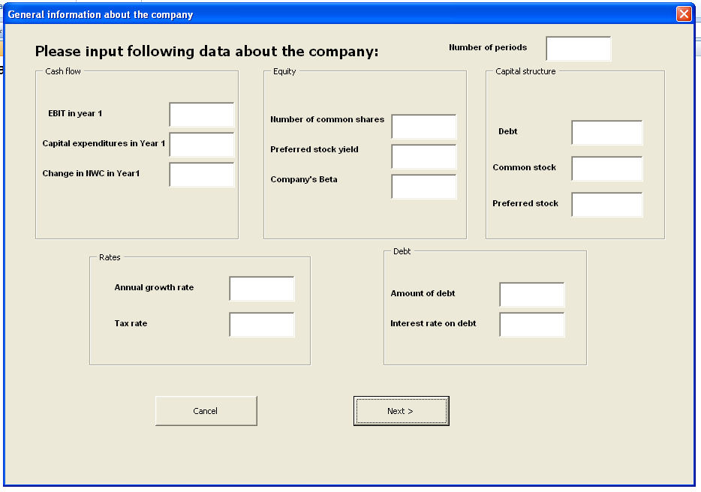
Capital structure
A mix of a company's long-term debt, specific short-term debt, common equity and preferred equity.
Debt – percentage of debt in total capital (debt/(debt+equity))
Common stock – percentage of common stock in total capital (common stock/(debt+equity))
Preferred stock – percentage of preferred stock in total capital (preferred stock/(debt+equity))
If there is no preferred stock in the capital structure user should indicate “0”.
Rates
Annual growth rate – annual business growth/decline rate adjusted for the inflation. It would be more accurate to use multi-stage growth/ declining model, rather than use just one rate for evaluation.
Tax rate – current tax rate on business.
Debt
Amount of debt
Interest rate – in accordance with company’s credit rating (AAA, BB,BBB) and other conditions user should indicated cost of debt for the company.

All rates, percentages should be indicated in this form in decimals.

EBIT for year is taken from form 1 and entered into the period #1 column. EBIT for next periods calculated by multiplying the previous period EBIT by (1+growth rate).
EBIT _{year} _{n} = (1+rate)*EBIT _{year} _{(n-1)}
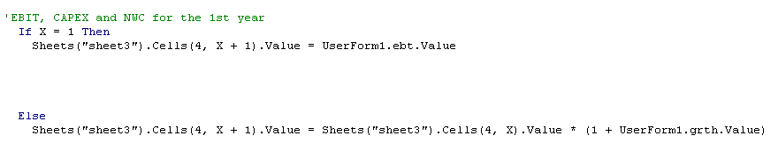
After all data entered into this form user should push enter, then next form will show up
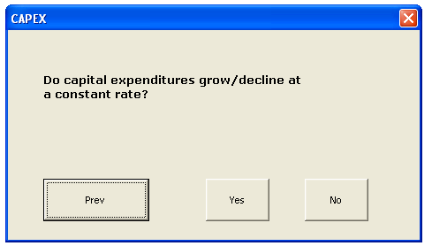
If user assume that Capital expenditures will grow/decline at a constant rate (sales growth/decline rate or some other rate) than he should push “yes” and enter rate into the next form.
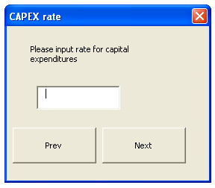
Rate should be indicated in decimal. If capital expenditures are declining then negative rate should be indicated in this form.
As mentioned earlier capital expenditures for year 1 are indicated in the first column marked as “Period 1”. See code below.
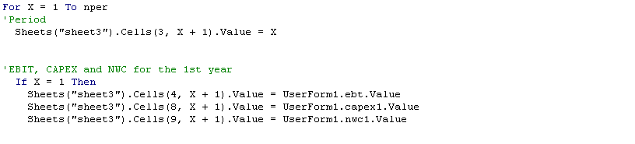
Then if user indicated that capital expenditures are growing/declining at a constant rate than Capex for following periods starting from year 2 to year x will be calculated using formula.
Capex _{year} _{n} = (1+rate)*capex _{year} _{(n-1)}
If capital expenditures do not grow/decline at a constant rate. And user is aware of planned capital expenditures for each year .
Than at the second form user should choose “no” and enter data, starting from year 2, into the following form:
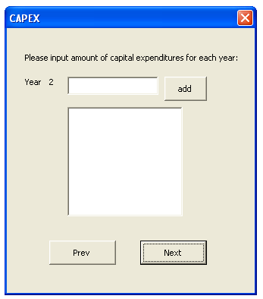
After planned capital expenditures data are entered into the field, user should press “Add” and add information about capital expenditures for other years. All data about capital expenditures for the indicated periods of time will be entered into the final table in respective periods.
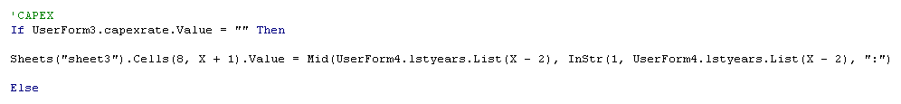
If user decided to change his approach he can go back by pushing “Prev” button and change entered data.
By clicking on “Next” button user will see following form:
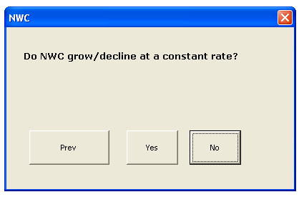
Usually NWC growths/decline with sales at a constant rate. In this case user should choose “yes” and enter the rate of growth/decline (in decimal) into the next form:
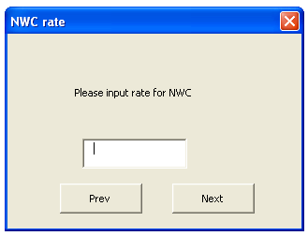
Then if user indicated that NWC will grow/decline at a constant rate than change in NWC for following periods starting from year 2 to year x will be calculated using formula.
NWC _{year} _{n} = (1+rate)*NWC _{year} _{(n-1)}
If NWC does not grow/decline at a constant rate, then at the following form user should choose “no”
and enter data, starting from year 2, into the following form:
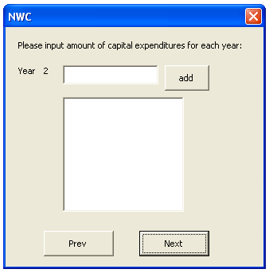
After planned NWC data are entered into the field, user should press “Add” and add information about NWC for another year. All data about NWC for the indicated periods of time will be entered into the final table in respective periods.

Tax expenditures for each period are calculated based on the tax rate entered into the first form and information about EBIT for the first year and EBIT growth rate
EBIT calculated for each period (described earlier) is multiplied by tax rate.
Then NOPAT (net profit after tax) is calculated based on information about EBIT and tax expenditures for each period. NOPAT = EBIT – tax expenditures
Depreciation
Then data about depreciation are obtained from the following form.
Initial cost of the equipment or initial capital investments in the project should be indicated in the field “initial cost of equipment”.
Along with initial expenditures, sometimes a company carries additional expenditures that should be capitalized and depreciated together with the initial cost of the capital investment.
Salvage value - is the estimated value of an asset at the end of its useful life. In accounting, the salvage value of an asset is its remaining value after depreciation. This is also known as residual value or scrap value. Sometimes salvage value equals termination costs and therefore is not taken into consideration when calculating depreciation.
Years of service – is useful life of the equipment in accordance with accounting rules.
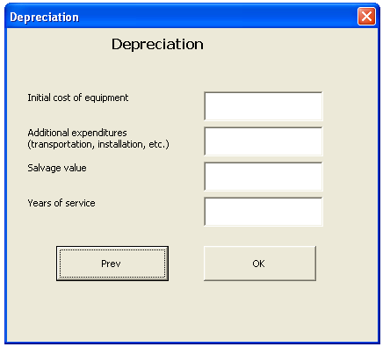
Straight-line depreciation is calculated as (Initial cost of the equipment + Additional expenditures – Salvage value)/ Years of service
If number of years in service is less than total number of periods indicated, then depreciation should be calculated only for number of years in service.
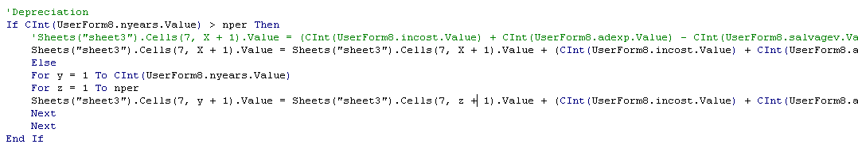
For capital expenditures during indicated period numbers calculated separately and should be indicated in the last form. Capex depreciation should be indicated starting from the first year.
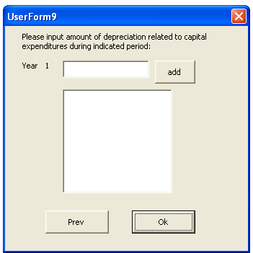
FCF
Free cash flow (FCF) is calculated in as:
NOPAT + Depreciation – Capex – NWC
Sheets("sheet3").Cells(10, X + 1).Value = Sheets("sheet3").Cells(6, X + 1).Value + Sheets("sheet3").Cells(7, X + 1).Value - Sheets("sheet3").Cells(8, X + 1).Value - Sheets("sheet3").Cells(9, X + 1).Value
Terminal value
Terminal value - the value of an investment at the end of a period.
Terminal value is calculated as last year’s FCF/ (WACC - growth rate)
WACC is calculated based on the information in the first form and data uploaded from 2 web-sites, growth rate is taken from first form.
WACC = Wp*Dividend yield + Wd*Interest rate on debt*(1-tax rate)+We*CAPM
Wp – percentage of preferred stocks in capital, number is taken from capital structure field
Dividend yield – is taken from “Equity” field – “Preferred stock yield”
Wd – percentage of debt in total capital, number is taken from capital structure field
Interest rate is indicated in “Debt” field - “Interest rate on debt”
Tax rate is indicated in “Rates” – “tax rate”
We – percentage of common stocks in capital, number is taken from capital structure field
CAPM is calculated by using following formula:
Re (CAPM)= Rf+Beta*(Rm-Rf)

Rm -market return rate is uploaded from S&P web-site and this is year-to-date return(YTD) on S&P 500 portfolio. (web site http://www.standardandpoors.com/indices/sp-500/en/us/?indexId=spusa-500-usduf--p-us-l--)
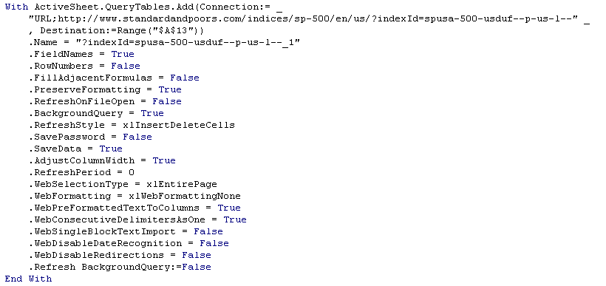
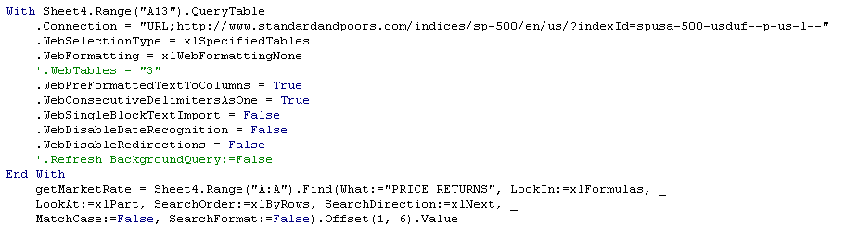
Rf – risk free rate is uploaded from Google finance web-site and this is return on 10-year treasury bonds. (web site www.google.com/finance)
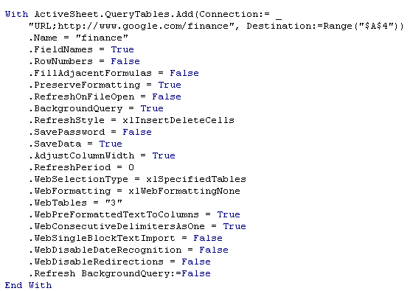
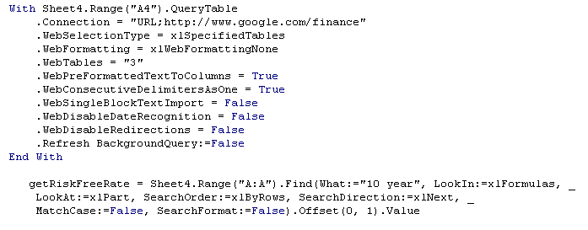
Beta – is indicated by user in the first form.
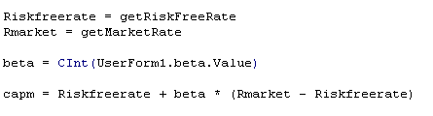
wacc = UserForm1.wpreferred.Value * UserForm1.pfrdstyield + UserForm1.wdebt.Value * (1 - UserForm1.taxrate.Value) * UserForm1.intrate + UserForm1.wcommon.Value * capm

Market premium (Rm-Rf)- for this assignment is taken from the indicated web-sites. Conceptually it would be more correct to use fixed Market Premium indicated by Ibbotson – 6.7%
Total cash flow
Total cash flow is the same as FCF except for the last year when last year’s FCF + terminal value.
NPV
Total cash flow discounted at the calculated rate (WACC) by using NPV formula .
This is value of the assets
In order to obtain value of equity debt should be subtracted of the calculated above number.
Debt amount was indicated by user in the first form.
Price per share
Price per share is (NPV-Debt)/Number of shares
Number of shares taken from the first form – “number of common shares”
Sheets("sheet3").Cells(16, 2).Value = (Sheets("sheet3").Cells(13, 2).Value - Sheets("sheet3").Cells(14, 2).Value) / Sheets("sheet3").Cells(15, 2).Value

Than following actions done to make this form look nice
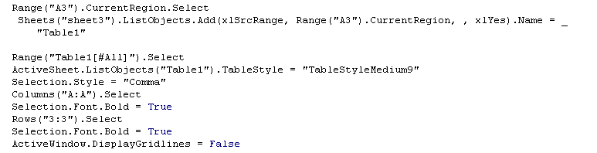

There is a “Clear” button on the spreadsheet; it allows clearing all calculated information from the table.
The “Save” button allows to save this spreadsheet to a different location
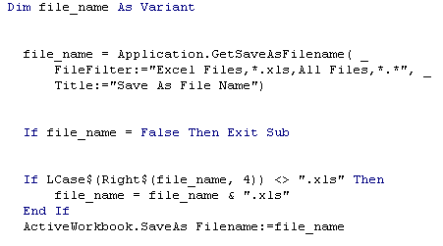
Final version of the report with calculations:
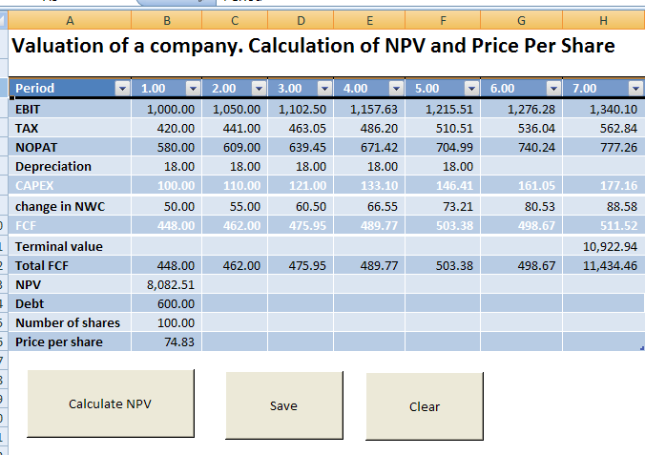
Summary
There were a lot of assumptions which were done in the calculation of NPV.
One thing which is not completely right is calculation of depreciation. If period indicated in the first form is greater than useful life indicated in the depreciation form, total depreciation in the final form doesn’t show correct depreciation for capital expenditures incurred during indicated period.
Also it would be useful to put different restrictions, like total capital structure (We+Wd+Wp) should not exceed 1, in order to avoid potential human errors (errors of data entry).

I learned a lot during this project. Things like loops, number of periods in formulas, calculation of depreciation for certain period of time and different options with capex and NWC were difficult, but this was a good learning experience. It is a nice brainteaser and it was great to have professor Allen’s help when I had problems with different codes.

