“Call” and “Put” Options Pricing
for Non-dividend Stocks

EXECUTIVE SUMMARY.

PROBLEM.
A few weeks ago for one of my classes we were assigned to do a spreadsheet calculating the price of a “Call” option. Even though the assignment did not take a lot of time, it was quite a challenge for some of us. Different formulas and approaches, all of that became a nightmare.
For a long time people who interested in Finance have struggled to find the best way to evaluate the price of an option. As we know, an option is a contract between a buyer and a seller that gives the buyer of the option the right, but not the obligation, to buy or to sell a specified asset (underlying) on or before the option's expiration time, at an agreed price, the strike price.
In return for granting the option, the seller collects a payment (the premium) from the buyer. Granting the option is also referred to as "selling" or "writing" the option.
- a call option gives the buyer of the option the right to buy the underlying at the strike price.
- a put option gives the buyer of the option the right to sell the underlying at the strike price.
Today there are many different models to evaluate the price of an option, but the most popular are the Black-Scholes Model and/or the Binominal (tree) Model.
SOLUTION.
After finishing the assignment, I decided to simplify the process as much as possible. Thus, the program can help you calculate not only the price of a “Call” option for non-dividend stocks, but that of a “Put” as well. Moreover, the program allows you to use the Black-Scholes Model and/or the Binominal (tree) Model.
The Black-Scholes Model. In the early 1970s, Fischer Black and Myron Scholes made a major breakthrough by deriving a differential equation that must be satisfied by the price of any derivative dependent on a non-dividend-paying stock. By employing the technique of constructing a risk neutral portfolio that replicates the returns of holding an option, Black and Scholes produced a closed-form solution for a European option's theoretical price. At the same time, the model generates hedge parameters necessary for effective risk management of option holdings. While the ideas behind the Black-Scholes model were ground-breaking and eventually led to Scholes and Merton receiving the Swedish Central Bank's associated Prize for Achievement in Economics (often mistakenly referred to as the Nobel Prize), the application of the model in actual options trading is clumsy because of the assumptions of continuous (or no) dividend payment, constant volatility, and a constant interest rate. Nevertheless, the Black-Scholes model is still one of the most important methods and foundations for the existing financial market in which the result is within the reasonable range.
As an option in the program, you may apply the Black-Scholes Model.
The second model is the Binominal Model, also known as the tree model.
The Binominal (tree) Model. Closely following the derivation of Black and Scholes, John Cox, Stephen Ross and Mark Rubinstein developed the original version of the binomial options pricing model. It models the dynamics of the option's theoretical value for discrete time intervals over the option's duration. The model starts with a binomial tree of discrete future possible underlying stock prices. By constructing a riskless portfolio of an option and stock (as in the Black-Scholes model) a simple formula can be used to find the option price at each node in the tree. This value can approximate the theoretical value produced by Black Scholes, to the desired degree of precision. However, the binomial model is considered more accurate than Black-Scholes because it is more flexible, e.g. discrete future dividend payments can be modeled correctly at the proper forward time steps, and American options can be modeled as well as European ones. Binomial models are widely used by professional option traders.

EXPLANATION OF THE PROGRAMM.
See the files below. To calculate the option price, please open the xlsm-file, press the Start button and follow the instructions.

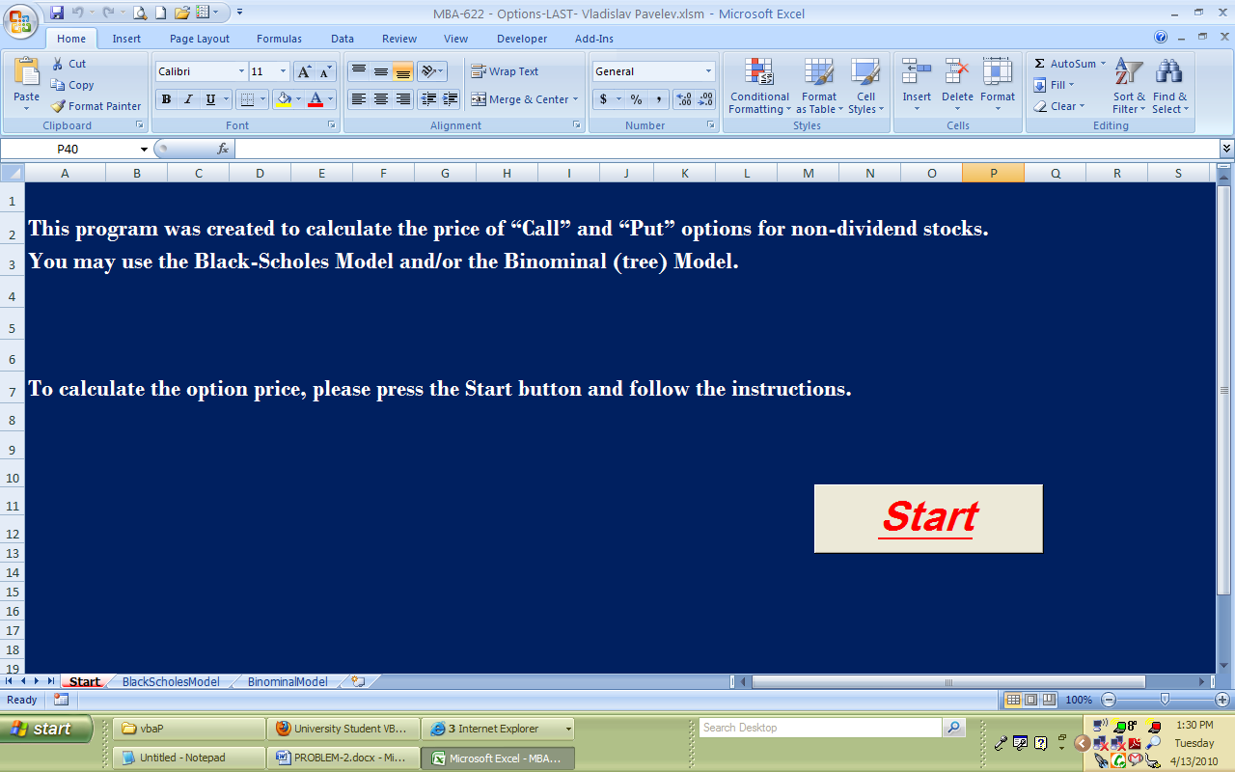

After you press the start button, you will see the following slide.

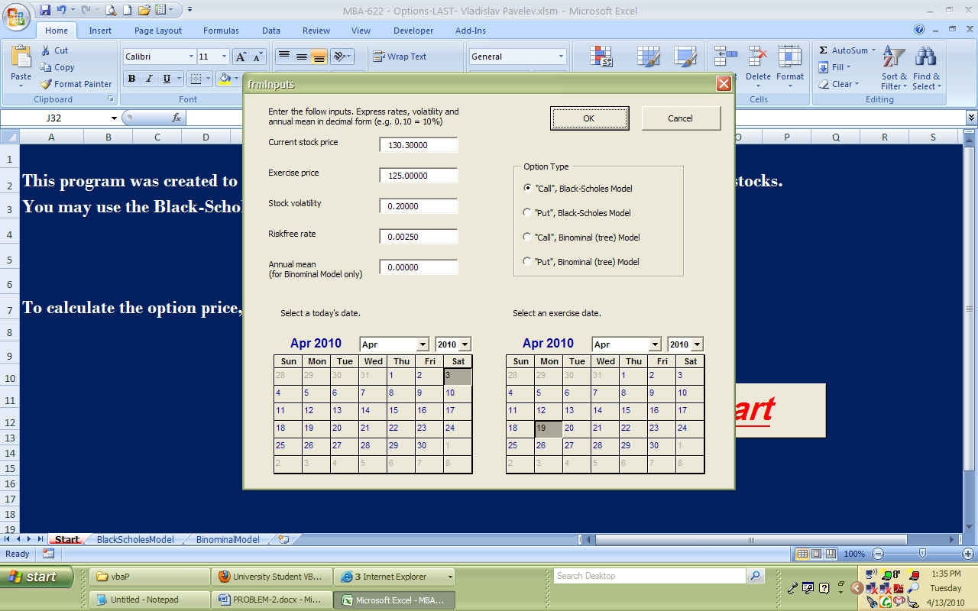

Please, choose the type of the option you are interested in, enter the required information such as prices of the stock, time, etc, and press OK.
Let’s choose a “Call” option and the Black-Scholes Model.

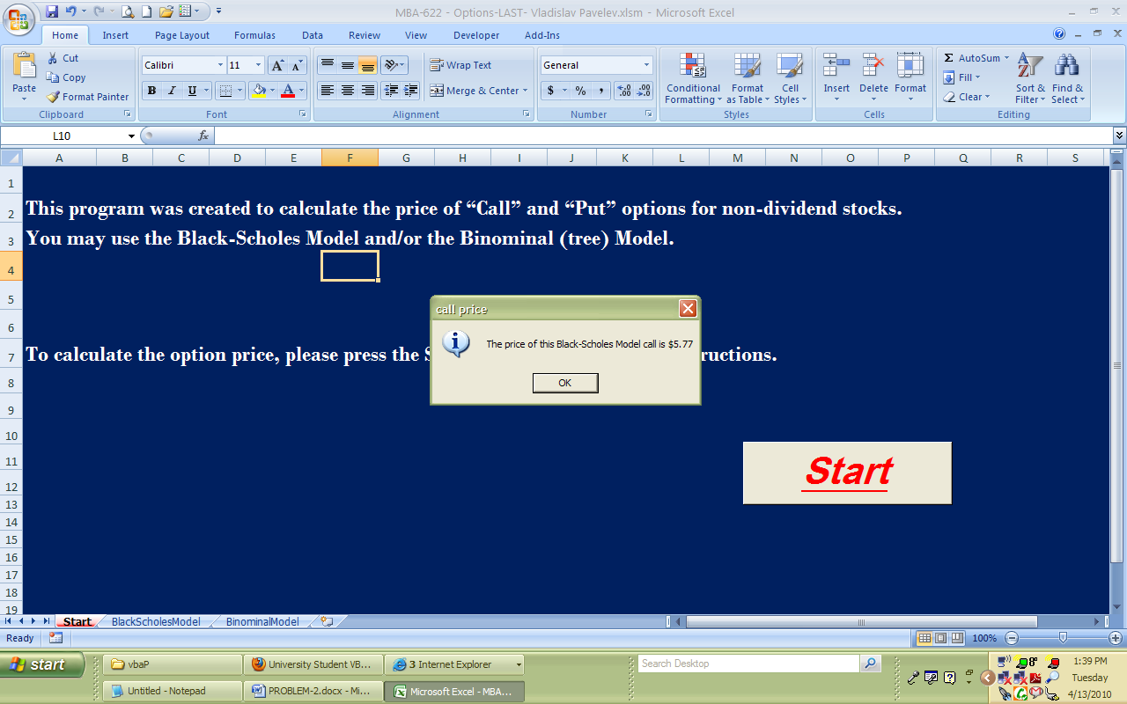

As you can see the price of a “Call” option is $5.77. If you use the Binominal (tree) Model, you will se that the price is the same ($5.77) as that of the Black-Scholes Model.

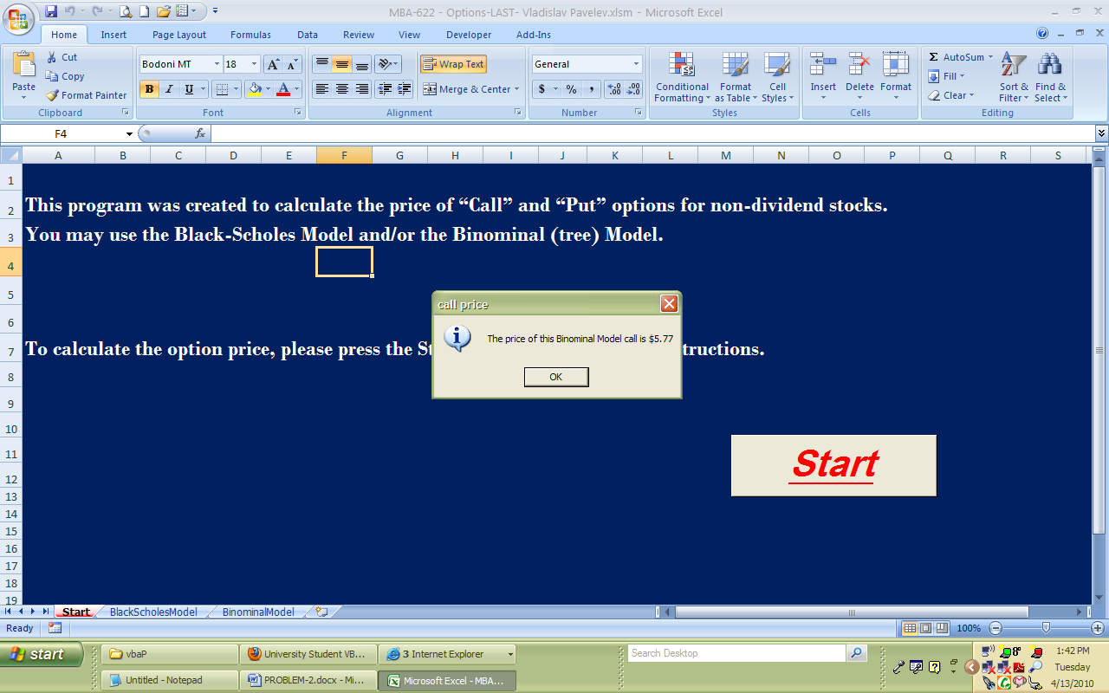
EXPLANATION OF THE CODE.

Now, let’s go the code. This is what the program is consisted of. Three sheets, one form and one module.

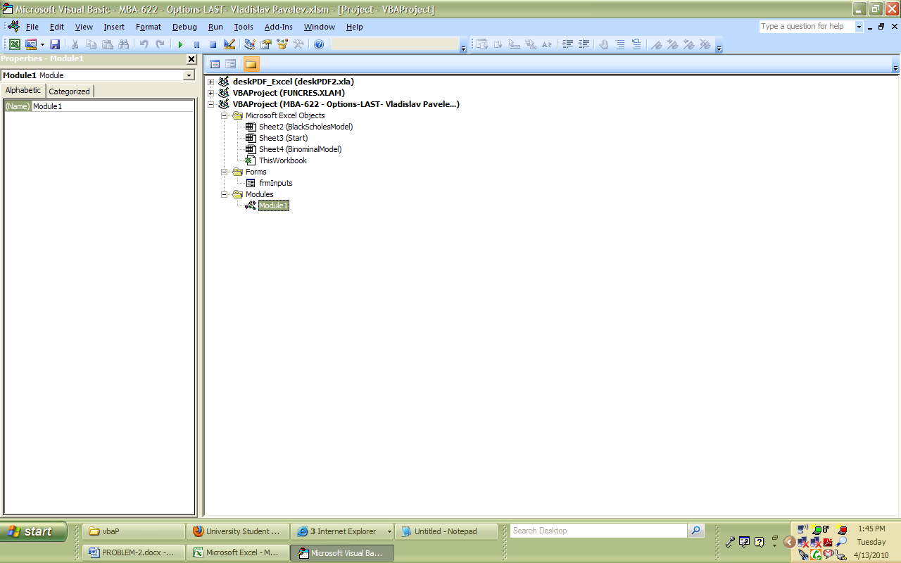

The form is very easy to create by using the Toolbox.

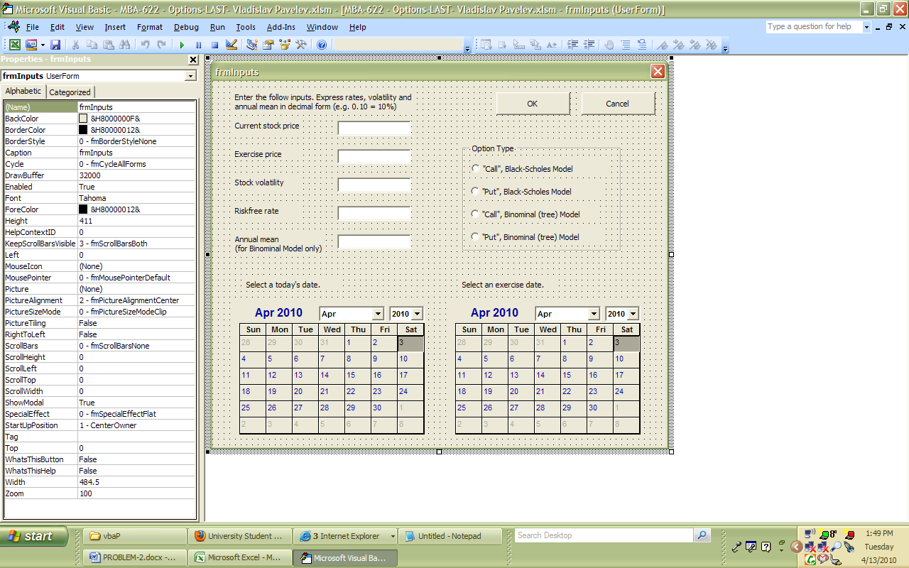

Then, I assigned each button and other fields to the code page (see below). As the calendars, I used additional control button from the Toolbox (the right click).

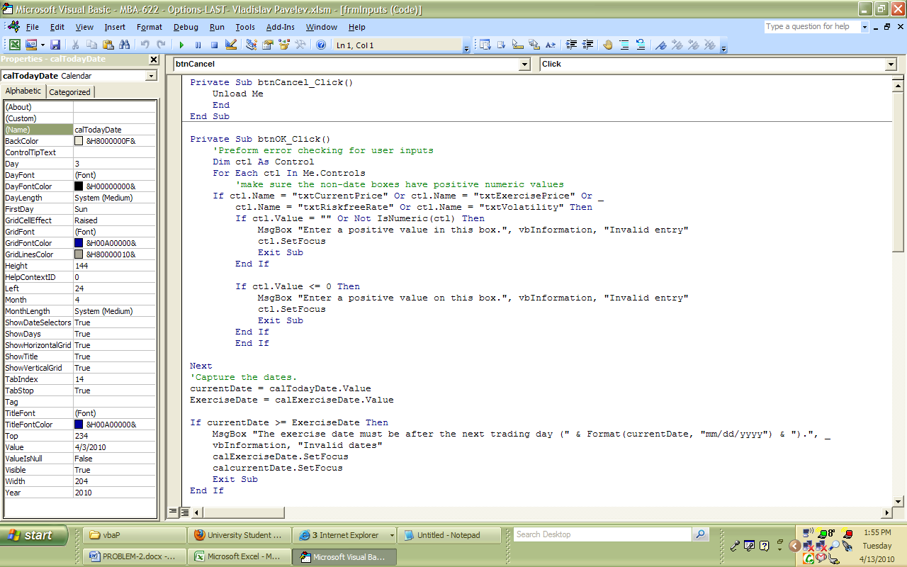

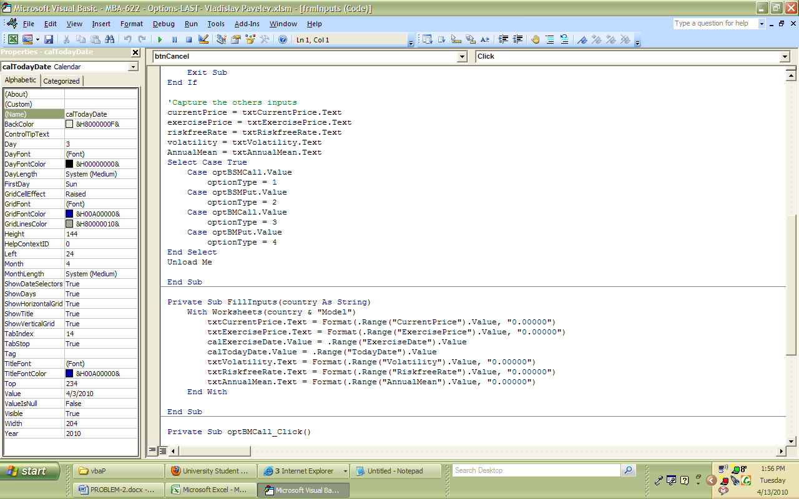

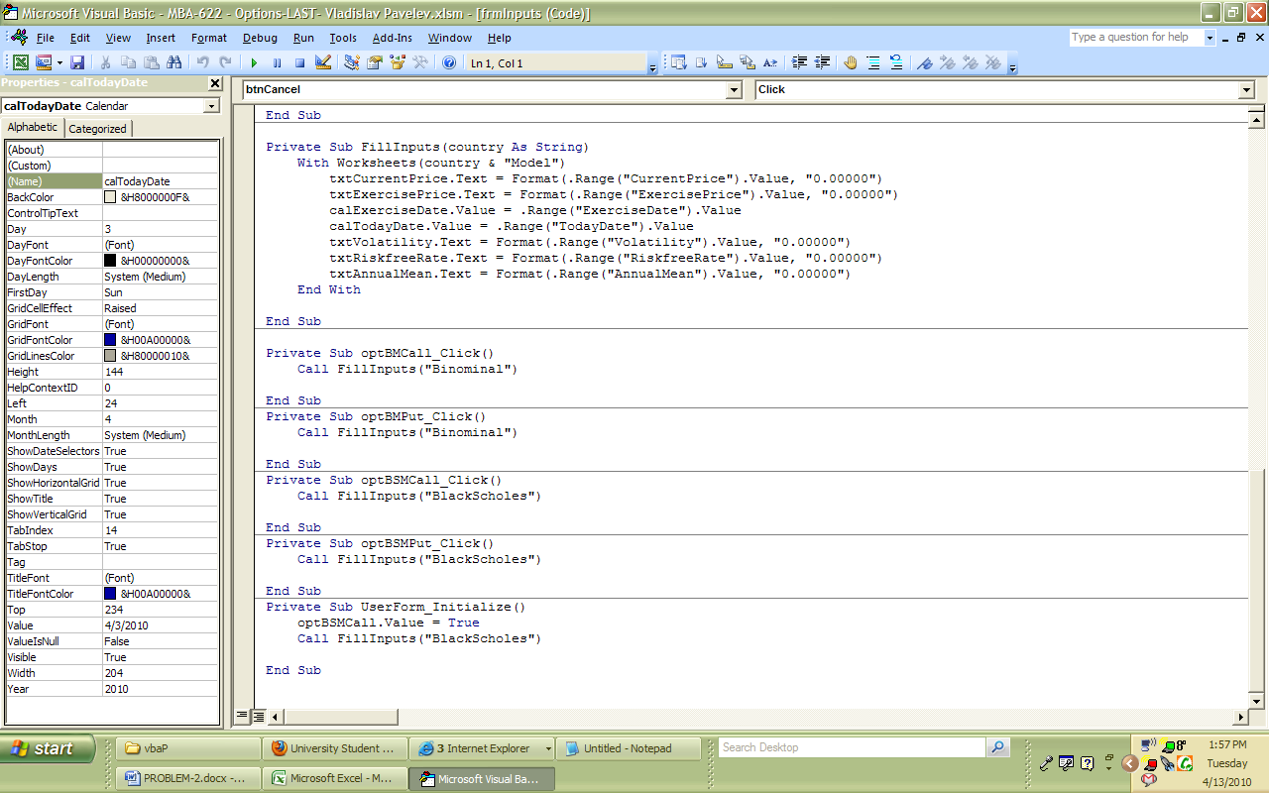

After that we are going to the Module1. We start with assigning variables and showing the input form.

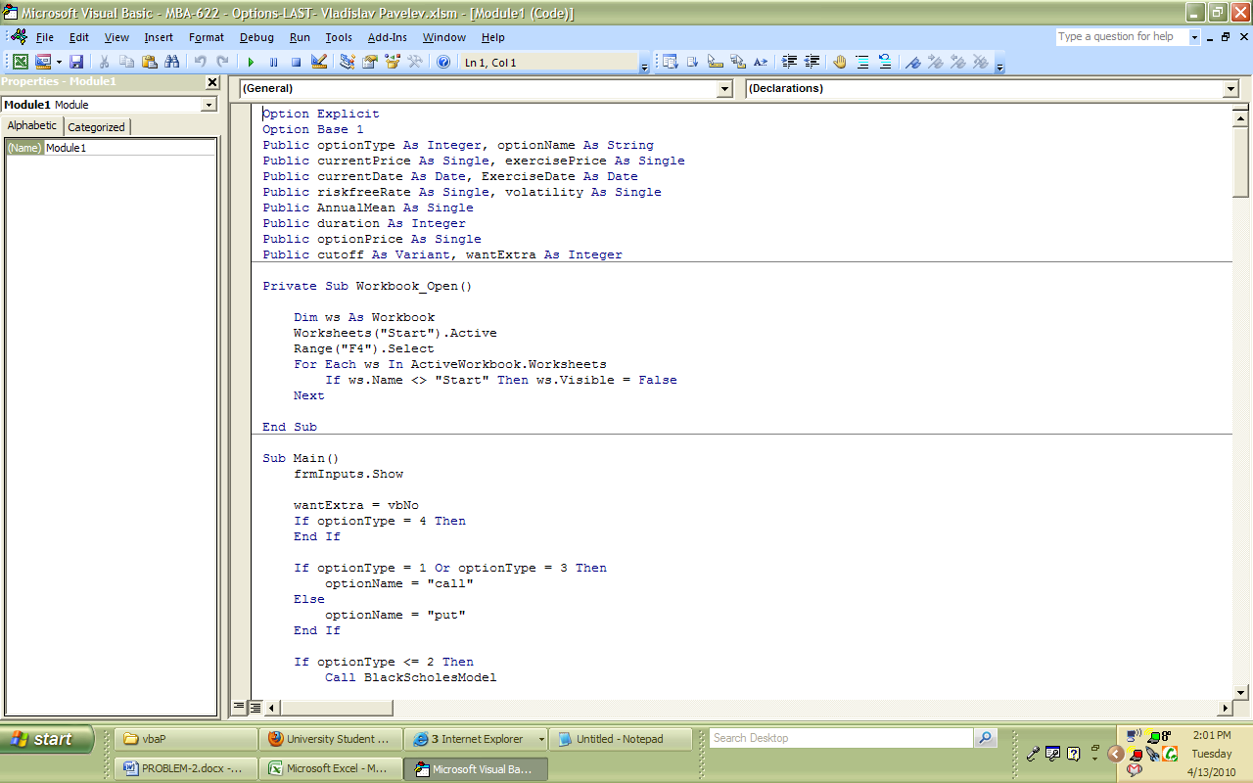

After all required information is in place, we choose the model and type of option we are interested in.
The Black-Scholes Model…

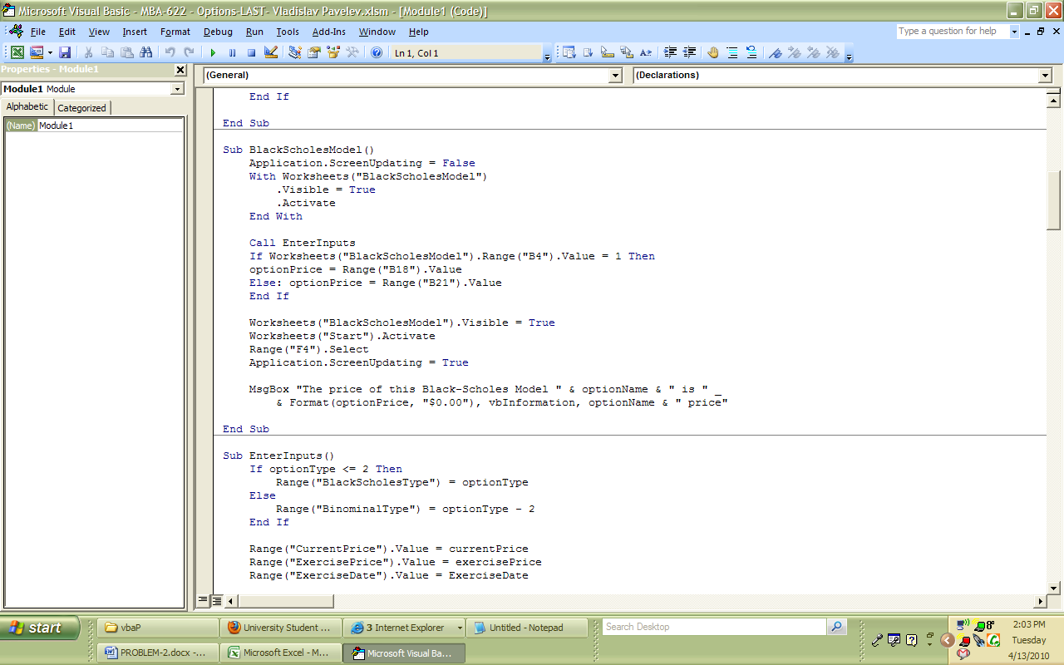

or the Binominal (tree) Model.

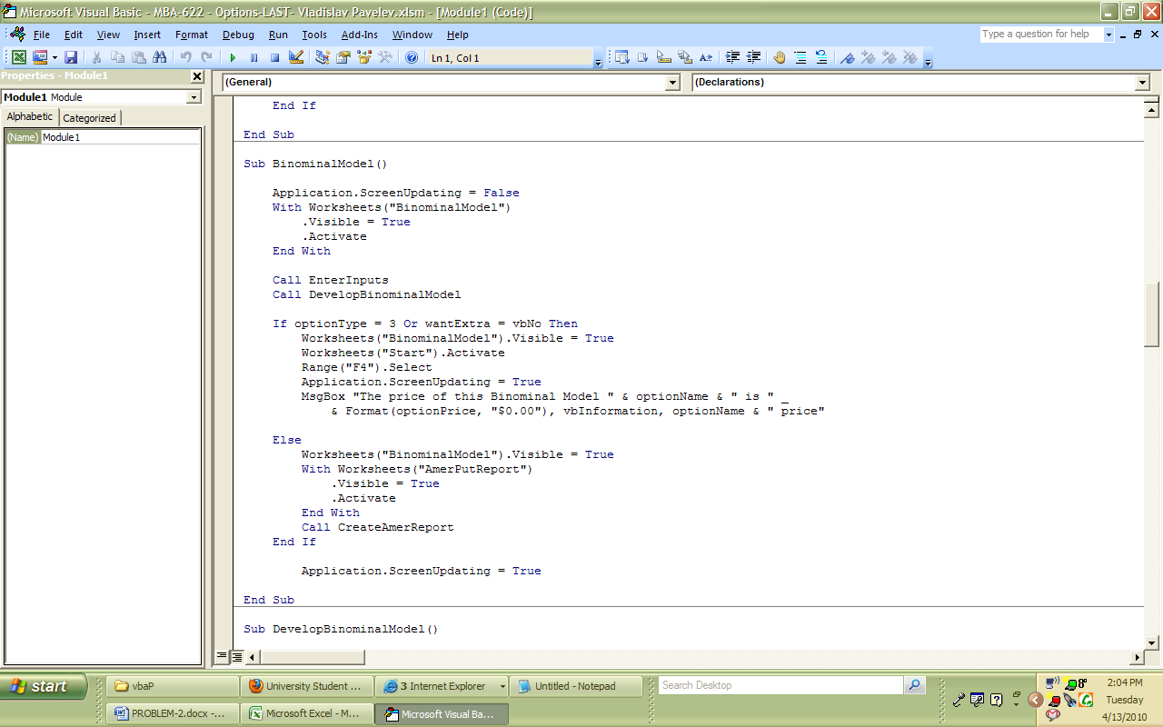

The interesting thing about the Binominal (tree) Model is that the program builds the “tree”.

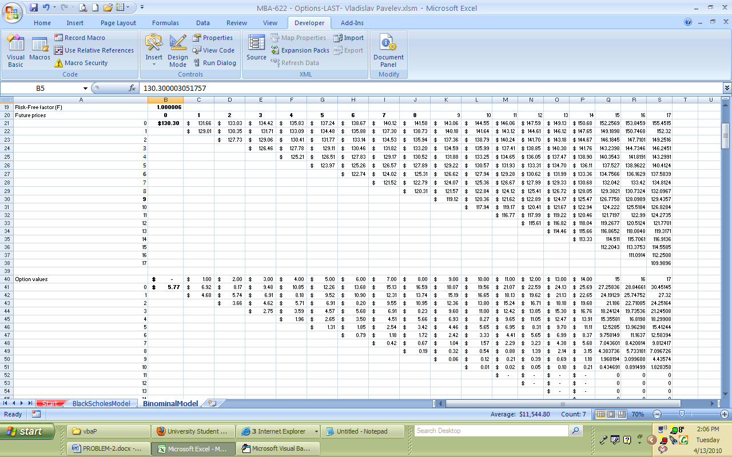

After choosing the type, the module, and pressing the OK button, the program calculates and builds the required price by using the code.

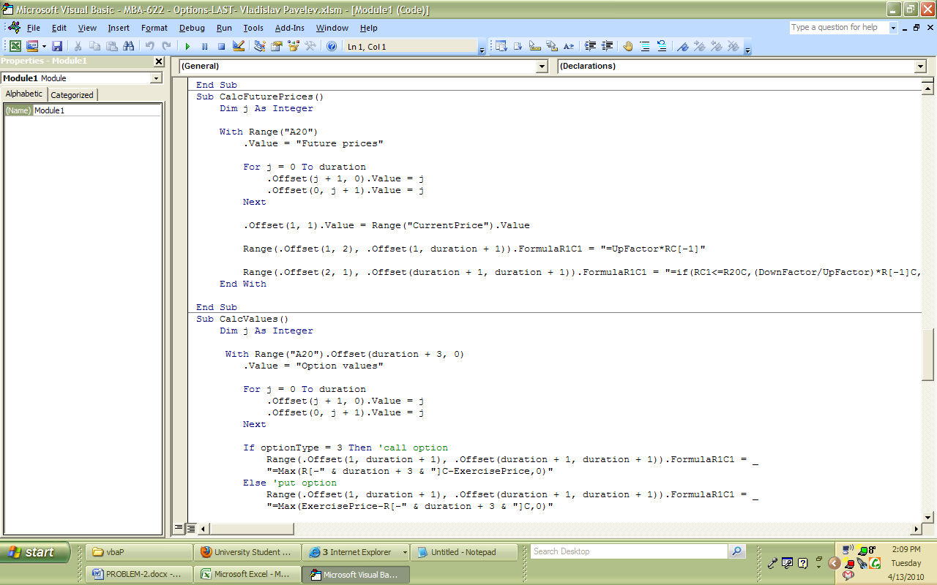

DIFFICULTIES and LEARNING.

Trying to make the program work I faced a few difficulties. One of them (the most significant) is that when I ran the program, the price of a “Put” option was exactly the same as that of a “Call” one.
The main reason was that the program used the same code to find both prices. It took me a while to find it and fix. From that I learned that even if a code looks good to you, you have to know the right answer and run a program a few times before it works appropriately.

