Calculating and Graphing the Efficient Frontier
for a Stock Portfolio

EXECUTIVE SUMMARY.

PROBLEM.
Another assignment a few weeks ago for one of my classes. A spreadsheet calculating and graphing the Efficient Frontier for portfolio of chosen stocks based the required return of the chosen stocks.
As we know, every possible asset combination can be plotted in risk-return space, and the collection of all such possible portfolios defines a region in this space. The line along the upper edge of this region is known as the efficient frontier (sometimes "the Markowitz frontier"). Combinations along this line represent portfolios (explicitly excluding the risk-free alternative) for which there is lowest risk for a given level of return.
Conversely, for a given amount of risk, the portfolio lying on the efficient frontier represents the combination offering the best possible return. Mathematically the Efficient Frontier is the intersection of the Set of Portfolios with Minimum Variance (MVS) and the Set of Portfolios with Maximum Return.
Formally, the efficient frontier is the set of maximal elements with respect to the partial order of product order on risk and return, the set of portfolios for which one cannot improve both risk and return.

SOLUTION.
After finishing the assignment, I decided to simplify the process as much as possible. Thus, this program was created to calculate and graph the Efficient Frontier for portfolio of chosen stocks based the average required return of the minimum and maximum of the chosen stock returns.
The region above the frontier is unachievable by holding risky assets alone. No portfolios can be constructed corresponding to the points in this region. Points below the frontier are suboptimal. A rational investor will hold a portfolio only on the frontier.

EXPLANATION OF THE PROGRAMM.
See the files below. To calculate and graph the Efficient Frontier, please open the xlsm-file press the Start button and follow the instructions.

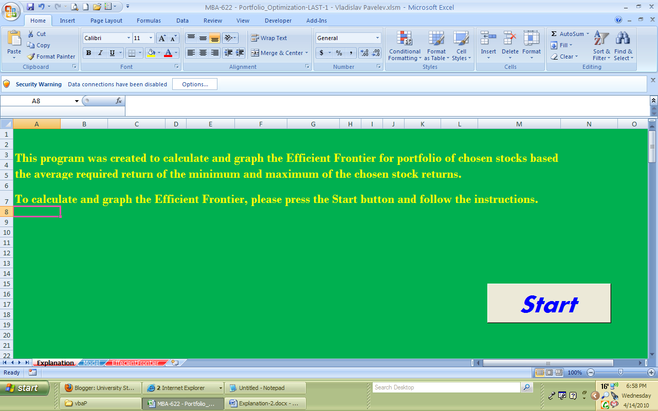

After you press the start button, you will see the following slide.

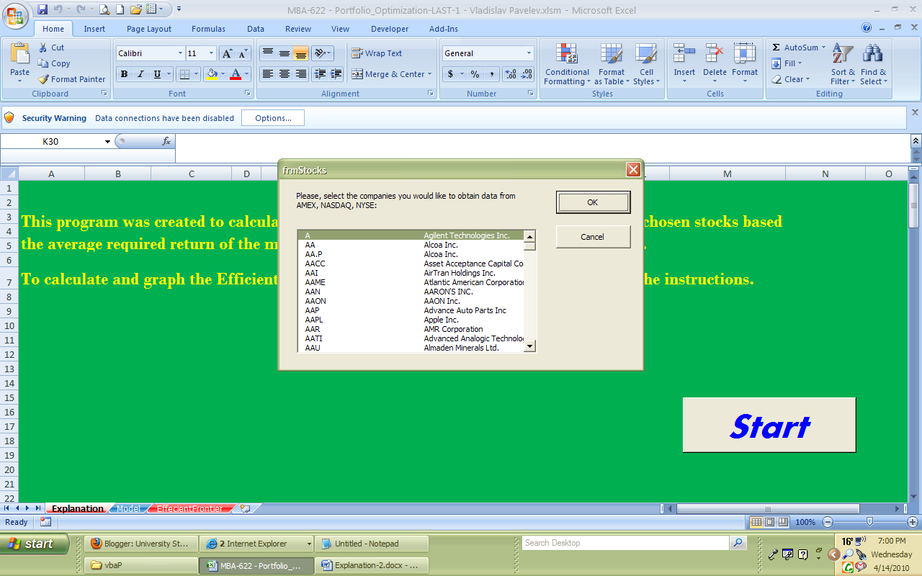

Please, choose stocks which you would like to use for your portfolio and press OK.

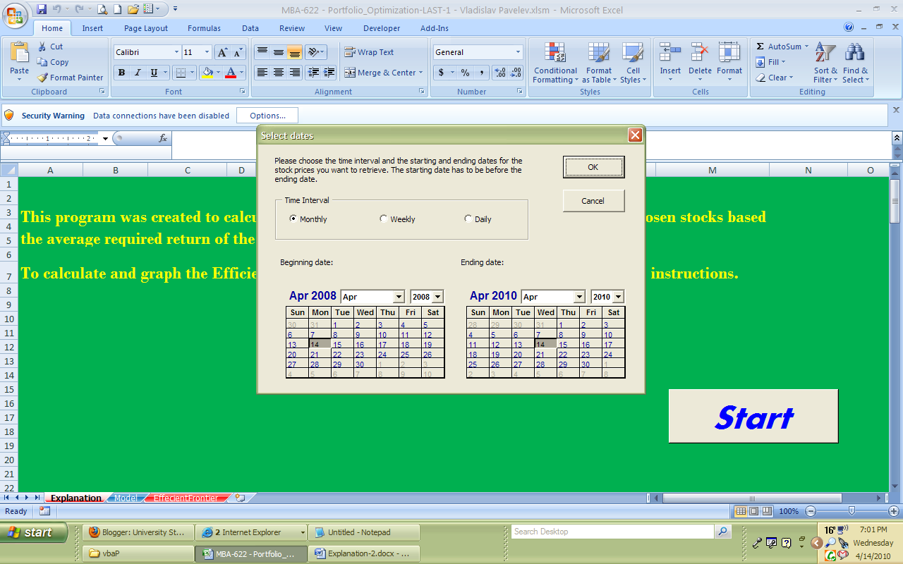

Choose time interval, beginning and ending dates, and press OK. The program will calculate and graph the efficient frontier.

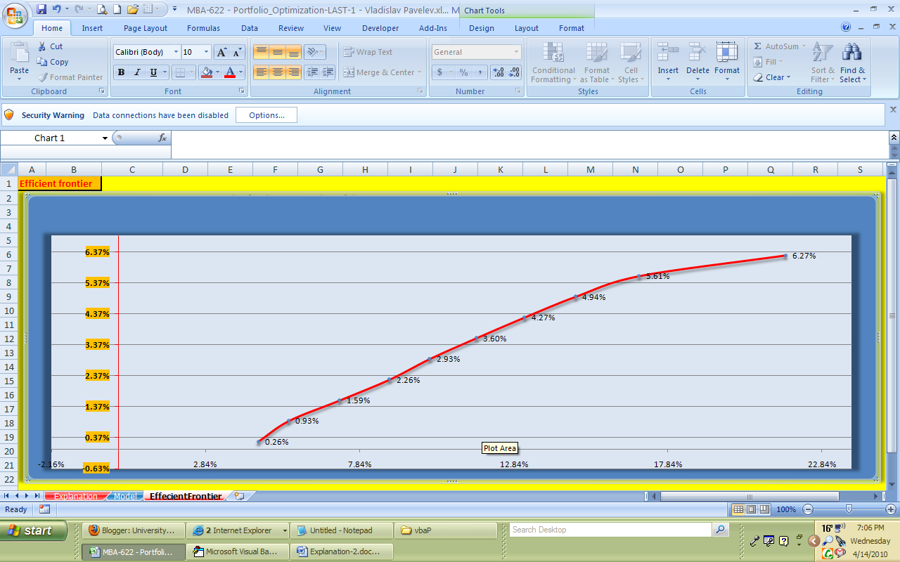

EXPLANATION OF THE CODE.

Now, let’s go the code. This is what the program is consisted of seven sheets, two form, one module and one reference.

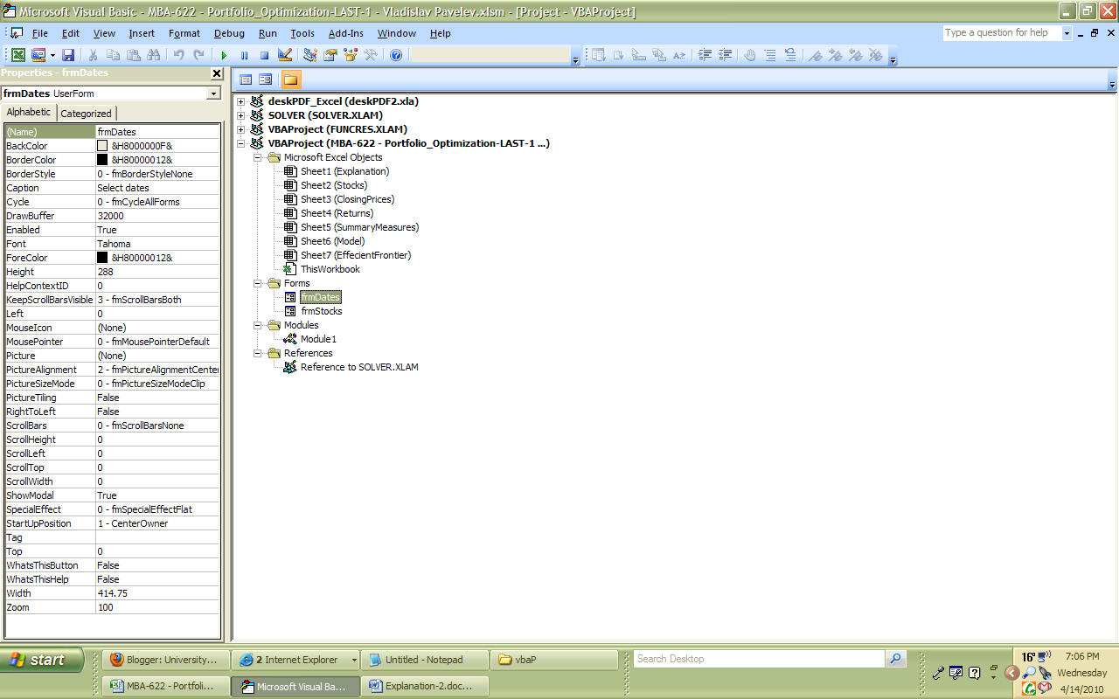

Then, I assigned each button and other fields to the code page (see below).
The forms are very easy to create by using the Toolbox. As for the calendars, I used additional control button from the Toolbox (the right click).

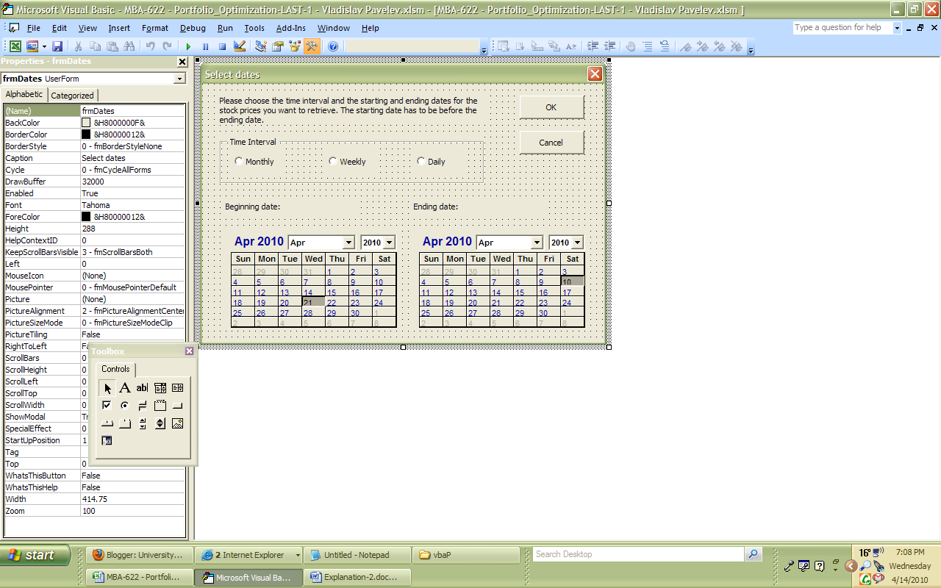

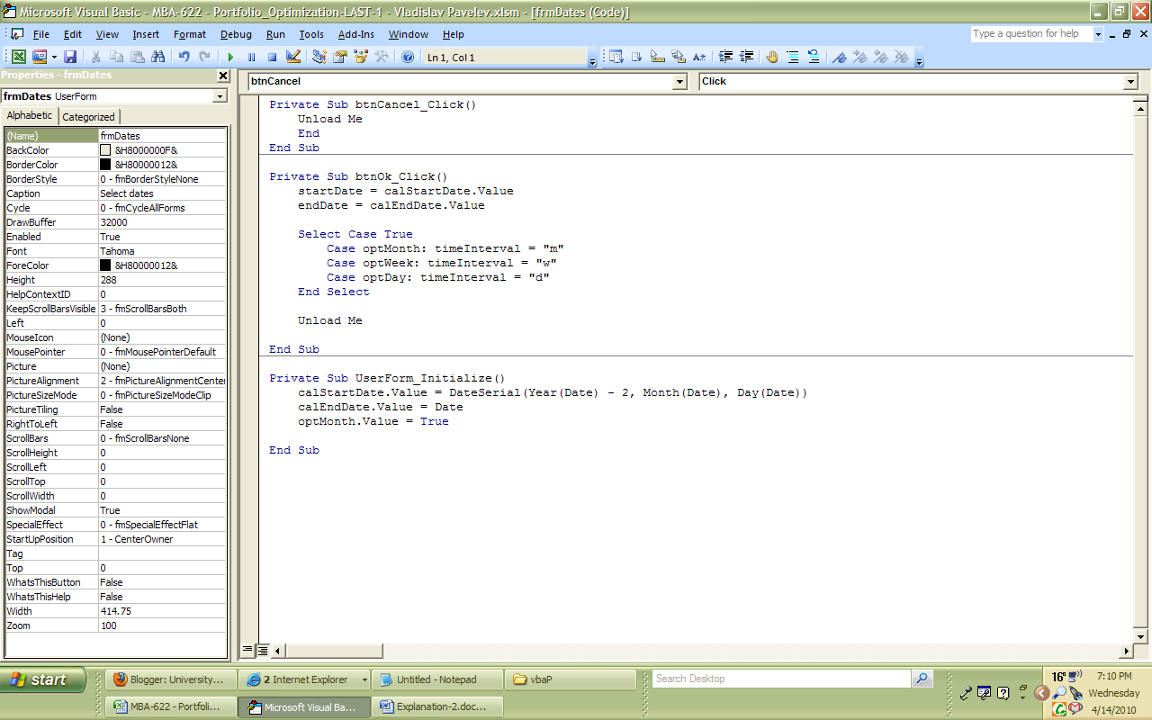

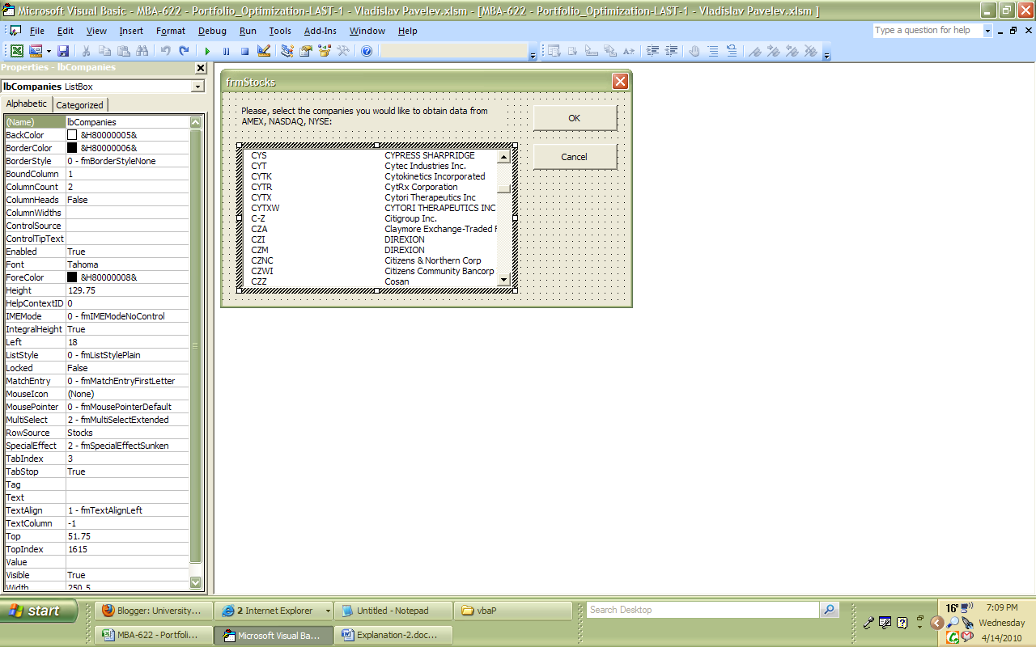

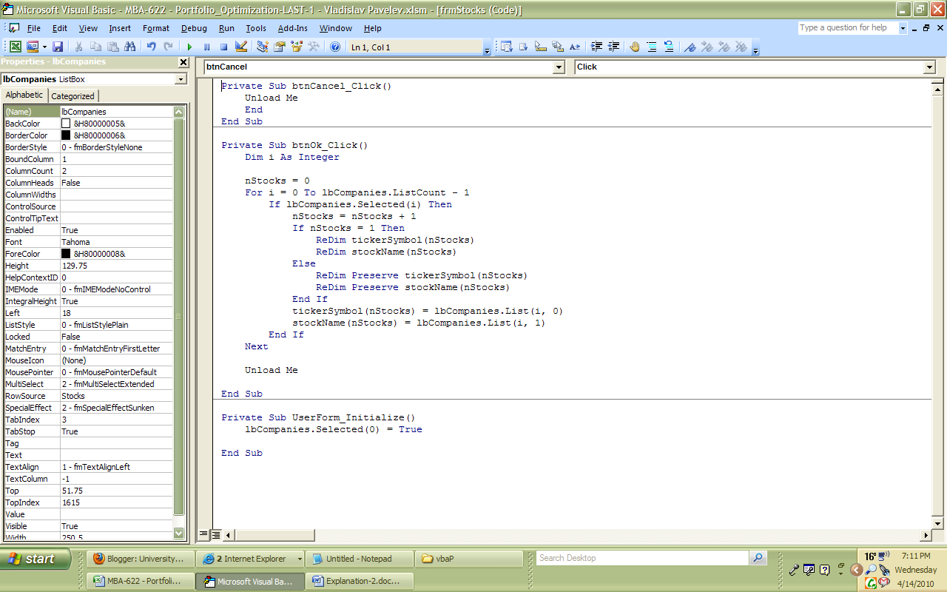

Then, when you choose the time interval, the program uses it in its calculation.

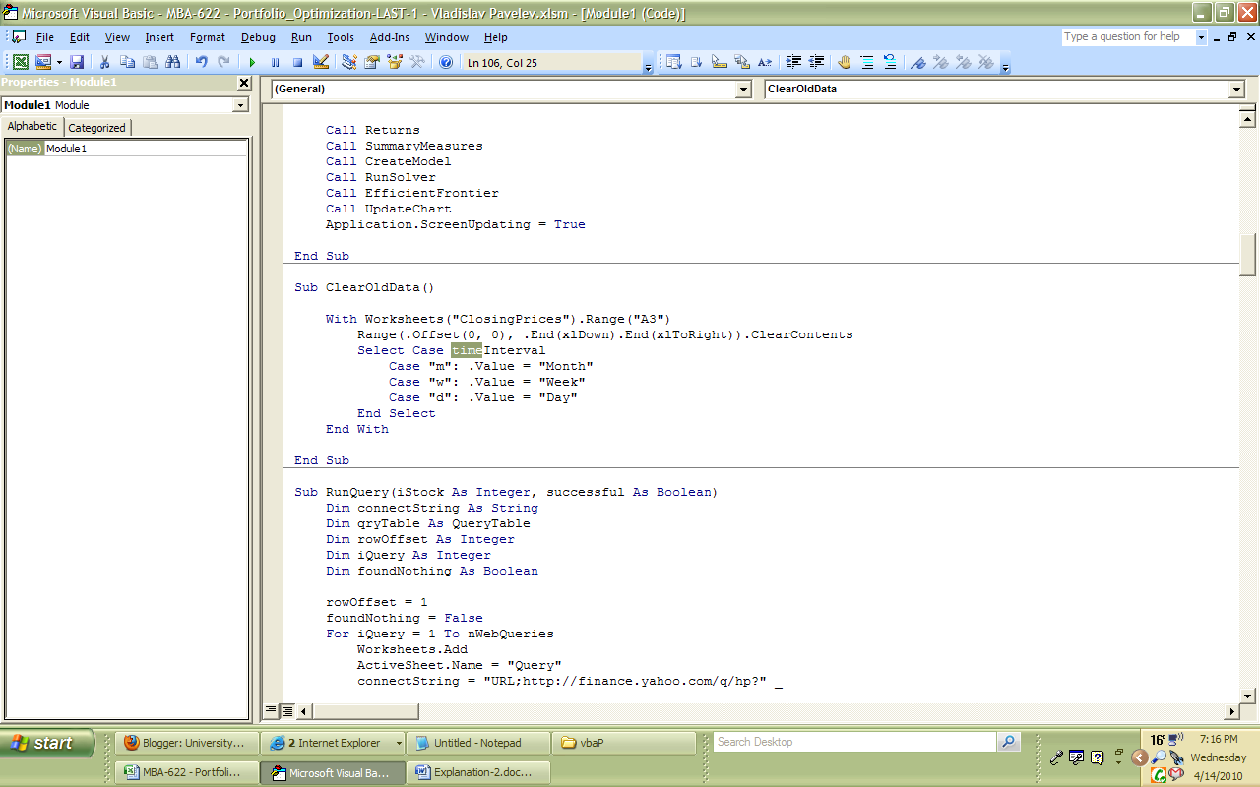

After that, the program retrieves required information from the Internet and plugs it in.

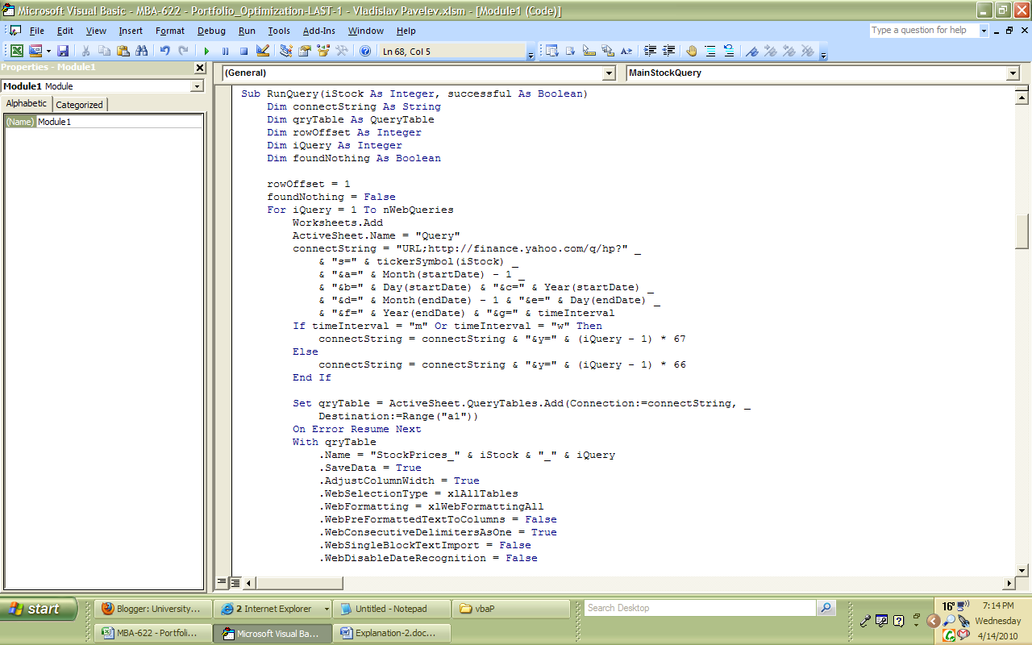

After calculating the means, St.Dev., Correaltions etc. the program uses them to create the Portfolio selection model.

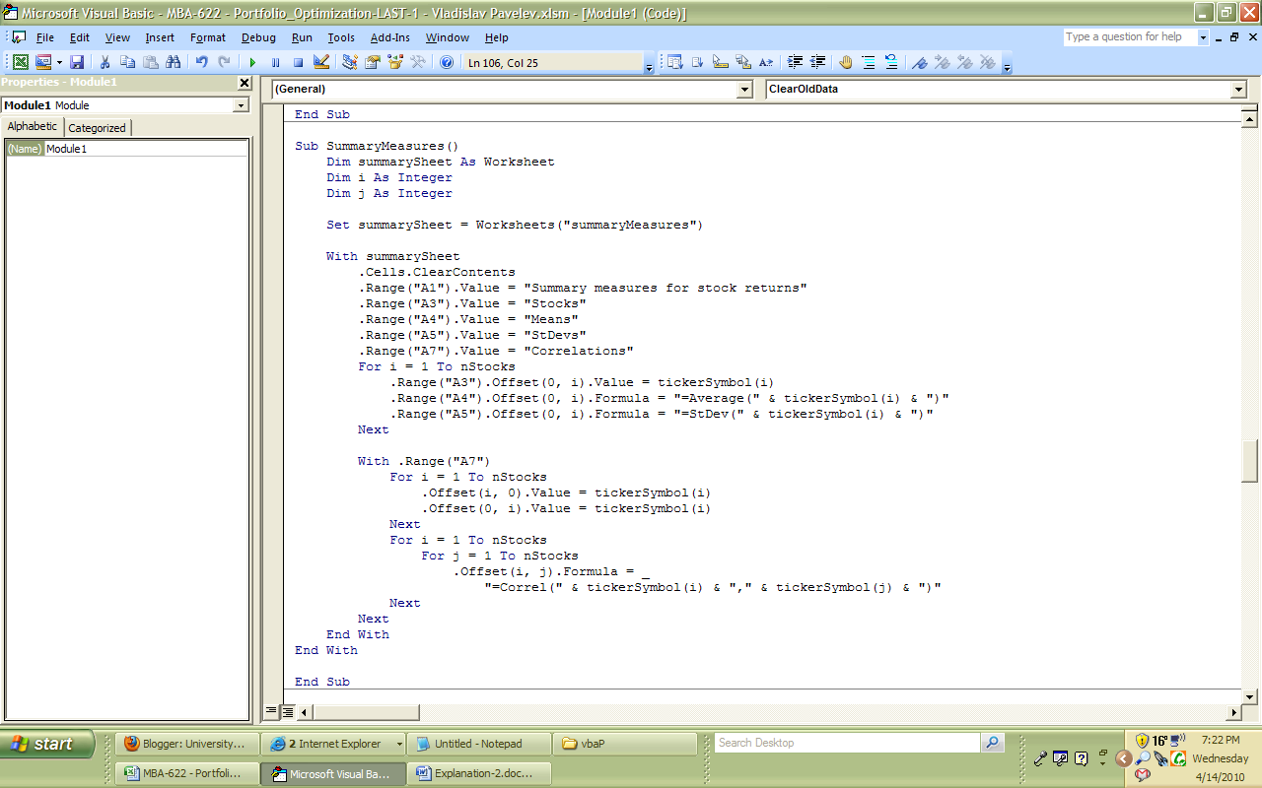

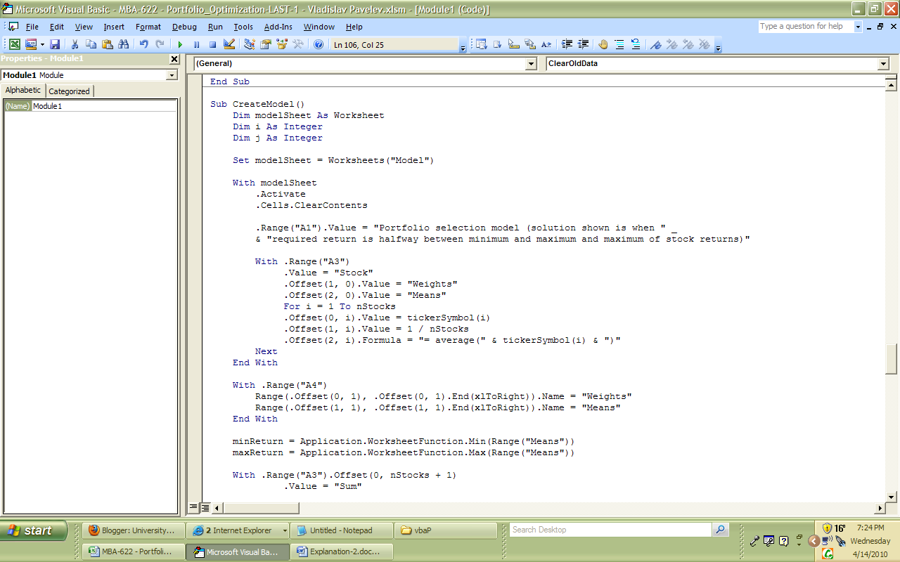

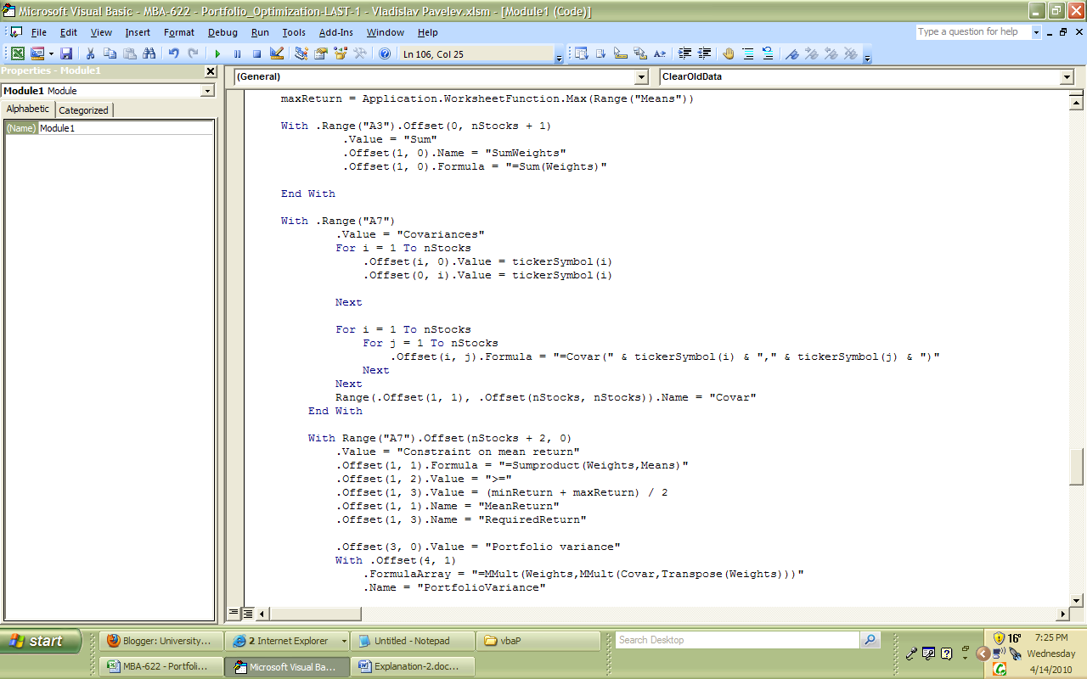

Then, the program runs the Solve from the Excel

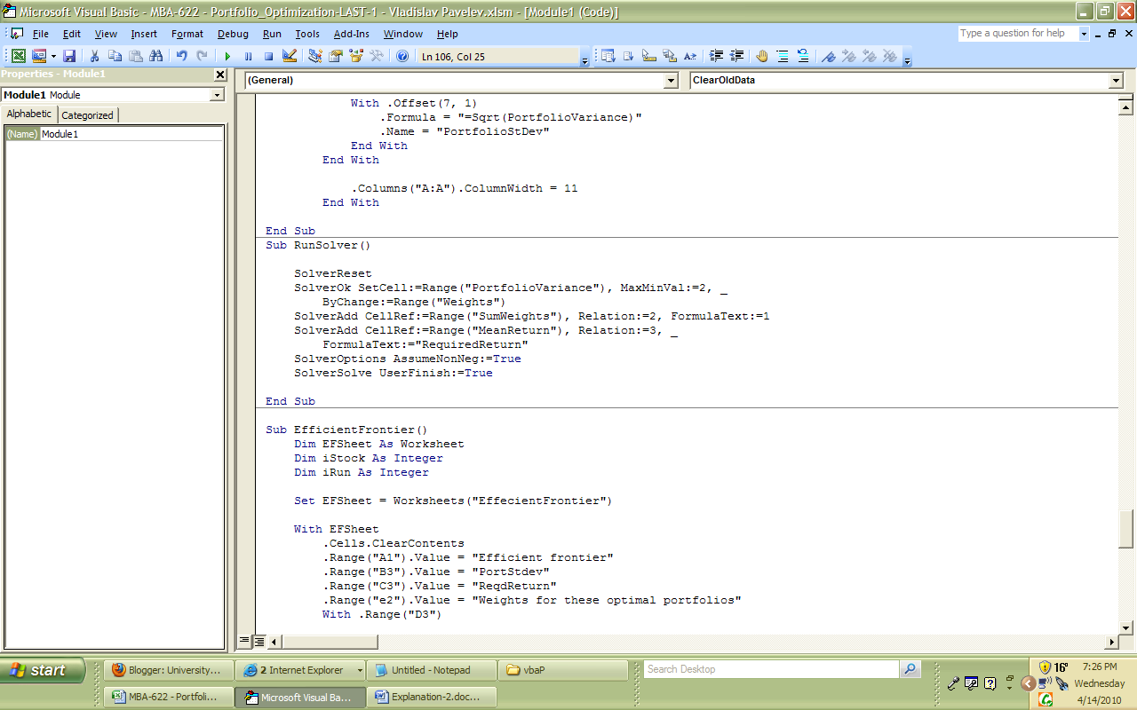

…. and graphs the efficient frontier….

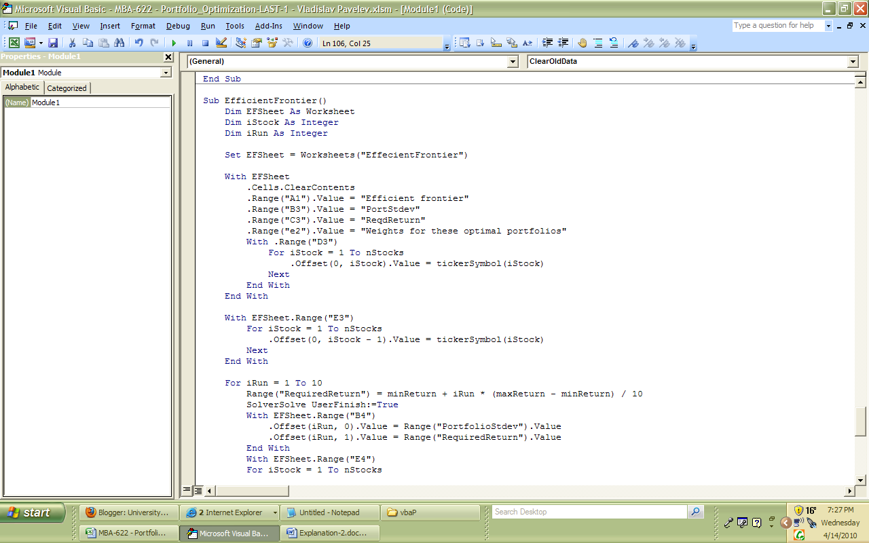

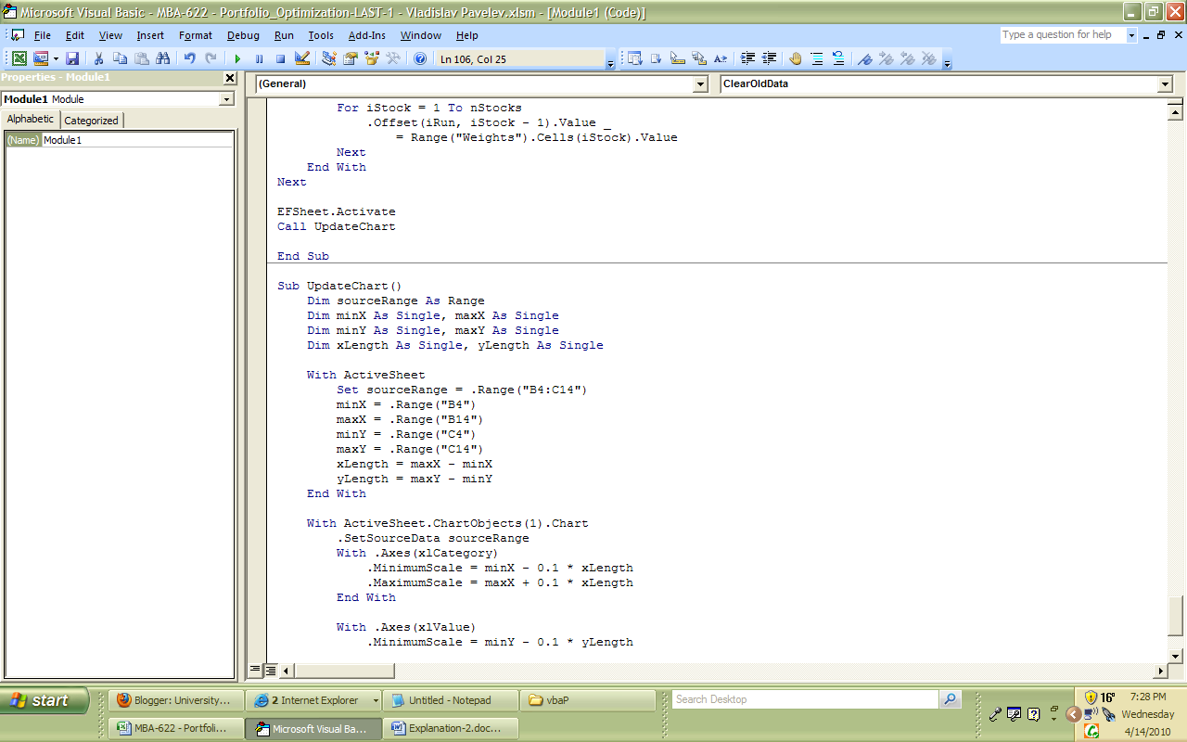

… which you can see on a slide at the beginning, pg 4.

DIFFICULTIES and LEARNING.

Trying to make the program work I faced a few difficulties. Some of them (the most significant) are as follows:
- when I ran the program, the correlations on the SummaryMeasures worksheet did not calculated right. The problem was that in the code I mistakenly assigned “i” for the row and a column, instead of “i” and “j” respectively.
- The code did not calculate the “Sum” on the Model sheet for “Weight”. The problem was that the code mistakenly assigned “SumWeight” in the Name Manager for two instead of one cells, so, the total sum doubled.
In both cases it took me a while to find and fix the mistakes. From that I learned that even if a code looks good to you, you have to check it a few times, know the right answer before executing the code and run a program a few times before it works appropriately.

