Gift Card Balance Reconciliation

Executive Summary
Since a recent change in law prohibited gift cards from expiring or charging monthly fees, these cards can now be acquired in large quantities and stockpiled for personal use over a long-term. These cards are issued for a wide variety of products and services including restaurants, retail stores, airlines, Ebay purchases, and general credit purchases such as American Express. Keeping track of these cards is often difficult, time consuming and complicated especially where cards are only partially used with remaining balance less than the stated face value. The owner must also be careful that cards are not compromised by improper transactions.
Fortunately, many card issuers now allow for online verification of the card balances however checking these balances on a periodic basis for a large number of cards and comparing the balance to one’s record is very difficult.
The program I wrote will give the user a format to record card information and history including the current expected value of each card. It will then on demand look up the amount the vendor shows for the cards, compare these values to the expected value and highlight any discrepancies. Differences could then be investigated and reconciled.

Implementation
The following illustrations show the process used for the Red Lobster gift card. The basic process is the same for all websites, although the code differed based on the differing company card inputs and table balance outputs.
The first step was organizing gift card information from a variety of different companies in a consistent manner so that it was easily readable, regardless of the digits in the card or pin number. It also had to be organized so that as cards were added or subtracted from the list it would still be possible to verify the recorded balances.

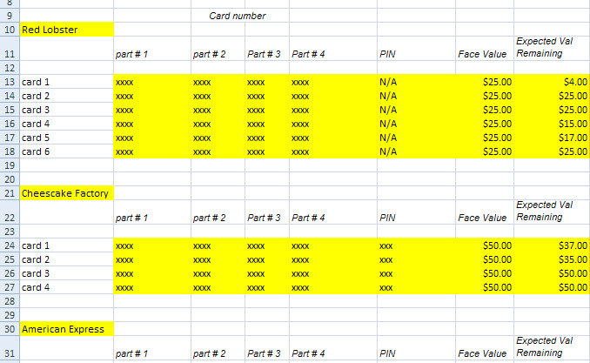
This gift card information was then pulled from this excel sheet using a 2 dimensional array for each type of card along with a "do while loop" that executed for as many cards as were listed for each company.
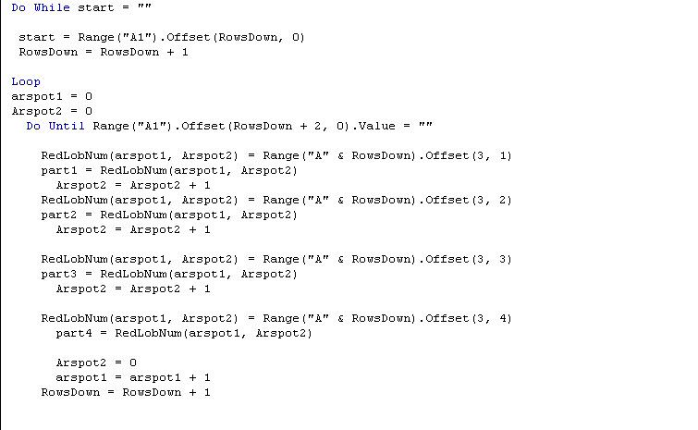
As the data from excel was put into an array it was then entered into a subroutine that went to each company's website in order to verify the card balance.
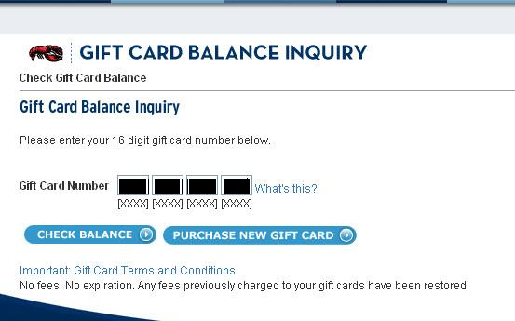

This process was also completed within the same loop, so that the program would pull the data from the site for each card.
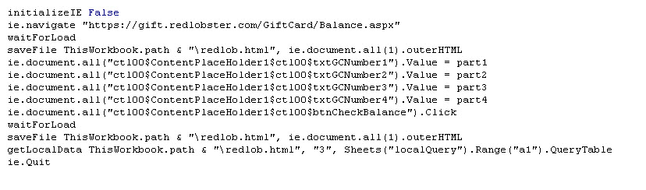This process is done so that the user does not view the browser, but will merely see the result. In order to retrieve the card balance, not only did the forms have to be entered for each card, but the data had to be saved in such a way that it would be retrievable locally. It was necessary to create an internet explorer object because the WebQuery wizard is not capable of accessing protected sites. The internet explorer object retrieved the data from password protected site
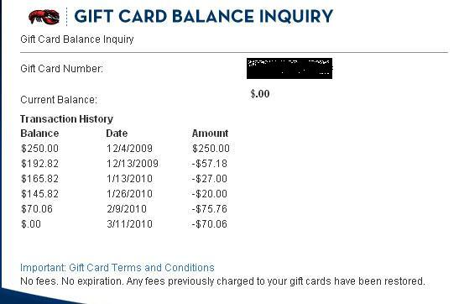

This table was saved as HTML in a local file.
After the file was saved locally it was put into a separate worksheet using the "getLocalData" function using the WebQuery wizard, which was now possible because the information was no longer protected.
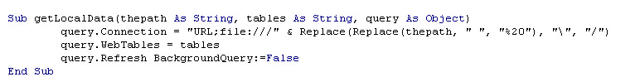
After the card balance information was saved on the "localQuery" worksheet it was transferred into the same row as the original card data so that it could be compared.
The code used to take data from the "localQuery" worksheet with Red Lobster
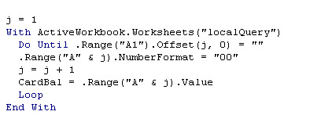
The result after bringing the balance to the original sheet
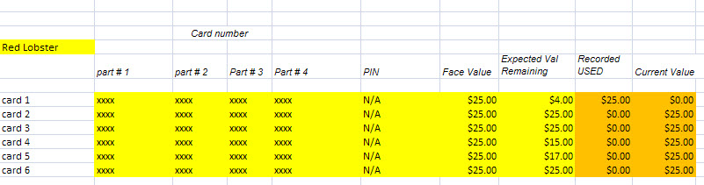

The comparison was also done as part of the same loop and compared the expected value remaining, with the actual value that was retrieved from the internet. Any differences between them were them highlighted in red, resulting in the following table for Red Lobster
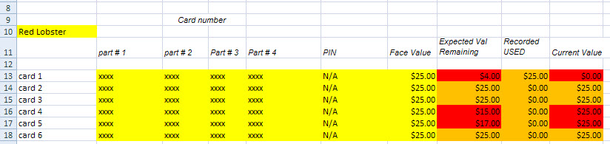

Although the examples given are for Red Lobster, this process is repeated for all listed gift card companies so that it is no longer necessary for the user to manually check each chard to see if there is a discrepancy between their recorded value and the value the company shows for the card. This will alert the user the any unaccounted for change in value with the press of a button.
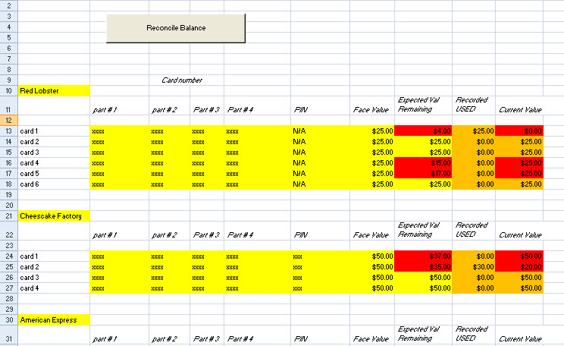

Learning and Conceptual Difficulties Encountered
The biggest challenge was in figuring out how to pull the card balance information from such diverse websites. The approach that worked for one site often was ineffective in another. For example, some sites do not readily identify the table where the balance is located and others display the balance on a new JavaScript window rather than on the same page. These kinds of issues created challenges that were also good learning opportunities.
Working with these different sites showed me fully appreciate just how powerful the tools are in VBA and thinking creatively with such tools as the internet explorer object can solve many problems.
Another challenge was that no two balances that were retrieved in a table were in the same format. This required code unique to each card company that would find where the balance was located.
For example, the data for Red Lobster appeared as:
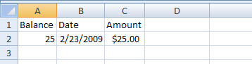
whereas the code for American Express was presented as:
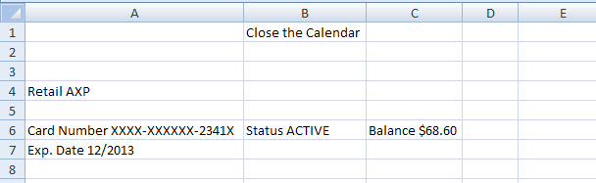

Potential Desired Elements Not Included:
There are a number of gift card company balances that cannot be automatically retrieved due to security features on the website. In researching this problem online and after seeing the professor, I know it is possible to download the security image or audio and have the user enter this information for the desired cards in order retrieve the balance. Unfortunately, for a company dealing with potentially well over a hundred cards this is not a viable solution.
Another potentially desirable feature would be to interact with the information using user forms rather than excel. However, this was not done as it only creates a marginal benefit considering what the user is trying to accomplish, which is to be able to very quickly reconcile the account balances.

