**New York City Apartment Complaint Listing**

Executive Summary

A real estate company (name withheld) manages apartment buildings in New York City. When there is an issue with the apartment or building, the tenants have two options. They can tell the building manager or file a complaint with the city. NYC Housing Department files posts the complaint on its website and schedules a visit to review the issue. If a complaint is filed through the city, building managers only know of it through viewing the website or after a visit from a city official.

The company has over 10 apartment buildings it manages. It would be burdensome to check for complaints on the buildings each day as they can be put up at anytime. A subscription to an email notification alert service is also too costly. The company’s employees are often out visiting the buildings and do not have access to the internet when they are out of the office. Also, since new complaints are not filed each day, the time spent manually checking is wasted if there is no new posting. The real estate company wants to know of the complaints before the city’s official visits. This way, any complaints can be resolved and the officials only need to visit once.

The VBA code automates the process to check for complaints. The procedure goes to two websites to check for complaints on all the properties. One website is for apartment specific problems and the other is for general building issues. A complaint history is imported into Excel for each location. The procedure checks for any new complaints and an email is sent with the details. The program can be scheduled to run on a daily basis and even multiple times a day. The real estate company now has a tool to be proactive in resolving tenant complaints.

Aaron Lund

MBA 614

Final Project Write-up

**New York City Apartment Complaint Listing**

The program was written to pull data from two websites. The first lists complaint history by apartment number. The second has complaint history for the building as whole. Each of these websites is maintained by New York City.

Department of Housing Preservation and Development

http://www.nyc.gov/html/hpd/html/home/home.shtml

Department of Buildings

http://www.nyc.gov/html/dob/html/bis/bis.shtml

To run the progrom, a listing of the properties in NYC is needed. The information for each website is the same: borough, street number, and street name. Figure 1 shows the needed property information. There are additional fields which will be explained later. This information is read into a two-dimensional array. The first dimension signifies which record is being read, e.g. the first record is stored as “address(0,x)”. The second dimension records all the values for that record: borough, street number, etc. The array is dynamic, in its size will adjust based on the number of property listings. It does not have unused address locations. The array along with other variables are declared globally. This allows its values to be referenced later in the program.

**Figure 1:** NYC Property Listings



With the property values stored in the array, the next step is to pull the complaint history from the websites. The data from Housing site is first and then the Building site. The code for each website is similar. The basic outline will be described and any deviations will be mentioned.

The main webpage requires the borough, street number, and street name to be inputted (see Figure 2). In order to do this, the source code for each website was searched for the input boxes. The “name” of the input boxes is different for each site. The data from the “address” array is inputted into the correct area. The search button is then “clicked” by the VBA code. As seen in Figure 2, the Borough is not a text field but a list. The correct borough is chosen by inputting the correct value into the field. So instead of the name, the borough reference number is inputted (see Figure 1). The reference number is the same for both sites. The code for each website is shown in Figure 3. Some areas have been highlighted for reference.

**Figure 2:** House and Building main websites

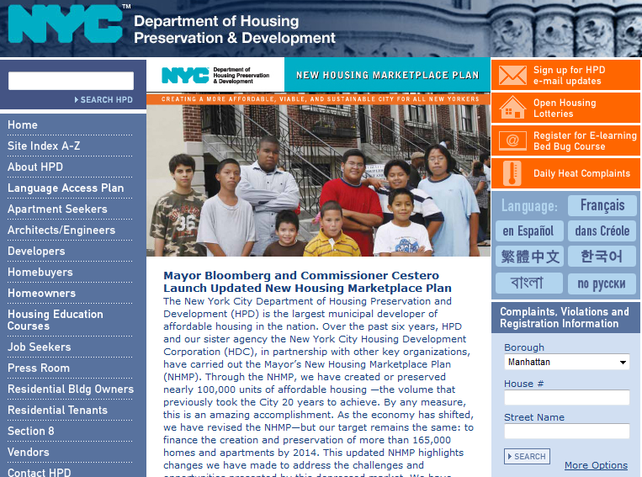

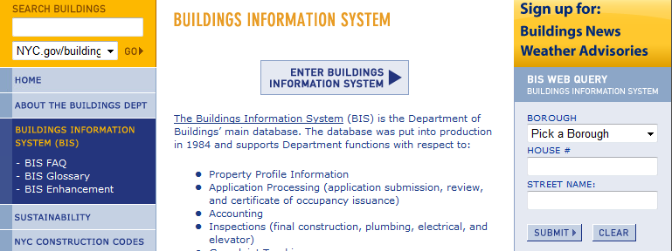

**Figure 3:** VBA code

Housing Website

Sub nycHome(site As Integer)

initializeIE False

ie.navigate "http://www.nyc.gov/html/hpd/html/home/home.shtml"

ie.Visible = False

waitForLoad

saveFile ThisWorkbook.path & "\Borough.html", ie.document.all(1).outerhtml

'Borough name, House number, and Street name

ie.document.all("p1").Value = address(site, 1)

ie.document.all("p2").Value = address(site, 2)

ie.document.all("p3").Value = address(site, 3)

ie.document.all("SearchButton").Click

waitForLoad

On Error Resume Next

ie.document.getelementbyid("lbtnComplaintHistory").Click

waitForLoad

saveFile ThisWorkbook.path & "\Complaint.htm", ie.document.all(0).outerhtml

ie.Quit

clearTabs site

pasteCell = "a1"

webTable = """dgComplaintHistory"""

pullTable site

End Sub

Building Website

Sub nycBuilding(site As Integer)

Dim activeCell As String

initializeIE False

ie.navigate "http://www.nyc.gov/html/dob/html/bis/bis.shtml"

ie.Visible = False

waitForLoad

saveFile ThisWorkbook.path & "\Borough.html", ie.document.all(1).outerhtml

'Borough name, House number, and Street name

ie.document.all("boro").Value = address(site, 1)

ie.document.all("houseno").Value = address(site, 2)

ie.document.all("street").Value = address(site, 3)

ie.document.all("enter").Click

waitForLoad

ie.navigate "http://a810-bisweb.nyc.gov/bisweb/ComplaintsByAddressServlet?requestid=1&allbin=" & address(site, 4)

waitForLoad

saveFile ThisWorkbook.path & "\Complaint.htm", ie.document.all(4).outerhtml

ie.Quit

webTable = 4

pasteCell = "h1"

pullTable site

End Sub

Once the Search button has been “clicked”, the user is taken to an informational page. Each of these pages is different (see Figure 4). The user can decide what information is wanted about the property. For the program, the correct “Complaint” link needed to be clicked. The housing website source code did not have a name for the link. So to click it, the form number was found using “getelementbyid” and then clicked (see highlight in Figure 3). The Building source code did not have an ID, so the code navigates Internet Explorer to the complaint website based on the Building Identification Number (BIN). This was already inputted into the “address” array (see Figure 1).

**Figure 4:** Website information pages

Housing Website

Website was shut down for maintainance

Building Website

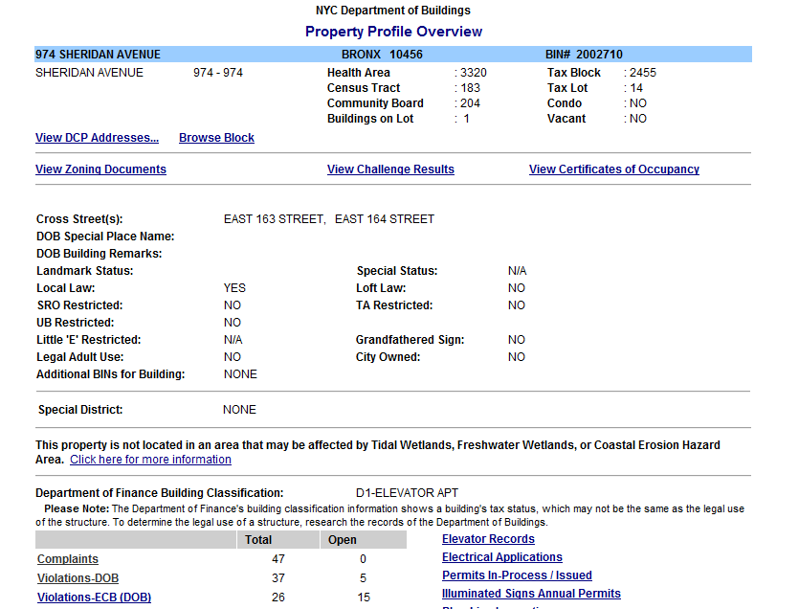

The next webpage contains the complaint history (see Figure 5). This website is saved as an HTML file. The file is written to the same directory as the Excel file. Once the file is saved, Internet Explorer is closed. At the end of the Housing sub-procedure, several functions are called. The first one clears the destination tab in Excel. Any old data is removed. This clearing function is not called at the end of the Building procedure. Both the Housing and Building procedures call a function to import the complaint tables into Excel, “pullTable”. In addition to calling the “pullTable” procedure, certain variables are set. These identify what cell to paste in and what table to pull from off the website (see Figure 3).

**Figure 5:** Complaint History on webpage

Housing Website

Website shut down for maintance

Building Website

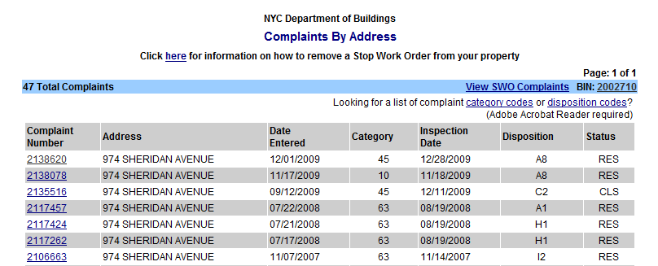

The “pullTable” procedure opens a new web query in Excel. The URL for the web query is the directory path for the save Internet Explorer file. The file name is the same for both the Housing and Building. This web query imports in the complaint history into Excel. This is done by selecting the correct table off the website. The table names are different for each website: dgComplaintHistory (Housing) and 4 (Building). The complaint history is imported onto the tab for each property listing (see Figure 6). These tabs are referenced by their names using the locations in the “address” array (code: Sheets(address(site, 2) & " " & address(site, 3)).Activate).

**Figure 6:** Snap shot of Excel tabs



The entire process mentioned above is repeated with a “For” loop for each of the property listings. Once this is complete, it tab will contain complaint history for both Housing and Building. The users of this program are only interested in new complaints. The next procedure looks at each tab and only pulls the current complaints. In this case, a current complaint is identified as being no older than five days. (This is because the code may not be scheduled to run each day. The company wants to capture any missed days.) Each complaint has an “Entered Date” which the code examines. If a complaint meets the criteria, it is then copied to the *New Complaint* tab. This enables the user to view all the recent complaints at once.

The *New Complaint* tab is cleared before any transfer of complaints. Its layout is similar to the property listing tabs, except that under the Housing complaints, the street address has been added. To avoid filling up the clipboard, new complaint are transferred through a range variable. Once again, the sheets are identified by the “address” array. The code also keeps track of the first available blank row on the *New Complaint* tab. This avoids copying over previous complaints. The entire sub-procedure is shown in Figure 7.

**Figure 7:** New complaint sub-procedure code

Sub newComplaints(site As Integer)

Dim currentRow As Integer

Dim theData As Range

currentRow = 2

Do Until ActiveSheet.Cells(currentRow, 1).Value <= Date - 5

Set theData = Range(ActiveSheet.Cells(currentRow, 1), ActiveSheet.Cells(currentRow, 1).End(xlToRight))

Range(Complaints.Cells(complaintrow, 1), Complaints.Cells(complaintrow, 6)).Value = theData.Value

Complaints.Cells(complaintrow, 7).Value = address(site, 2) & " " & address(site, 3)

complaintrow = complaintrow + 1

currentRow = currentRow + 1

Loop

End Sub

Once all new complaints have been transferred, an email is sent for each new complaint. The email is sent through Outlook. The message is generic with the complaint specific information added in. The emails for Housing and Building complaints are slightly different because of the available information. Figure 8 shows a sent email for a Housing complaint. With the emails sent, the user can now act on the complaint immediately.

**Figure 8:** Complaint email sent to user

**From:** Aaron Lund   
**Sent:** Tuesday, April 13, 2010 4:25 PM  
**To:** 'aaronelund@yahoo.com'  
**Subject:** New Complaint 4/13/2010  
  
Dear Sam:   
  
You have a new complaint.   
Address: 170 Vermilyea Ave   
Date: 4/10/2010   
Number: 5138976   
Apt: BLDG   
Condition: HEAT   
Detail: NO HEAT   
Location: ENTIRE BUILDING

**Conclusion**

The Excel file contains a button on the main tab to execute the code. Ultimately, the file will be set up to run automatically. This will be done by calling the execute procedure from the *ThisWorkbook* module. It will execute as an event at the start up of Excel. The event will also have Excel close once complete. The Excel file will be opened using the Schedule Task in Windows. For this assignment and sanity of any future students, the code will not execute once it is open. The real estate company which will use this code can schedule it to run any day and numerous times per day if they desire. When to run this code will be at the discretion of the real estate company.